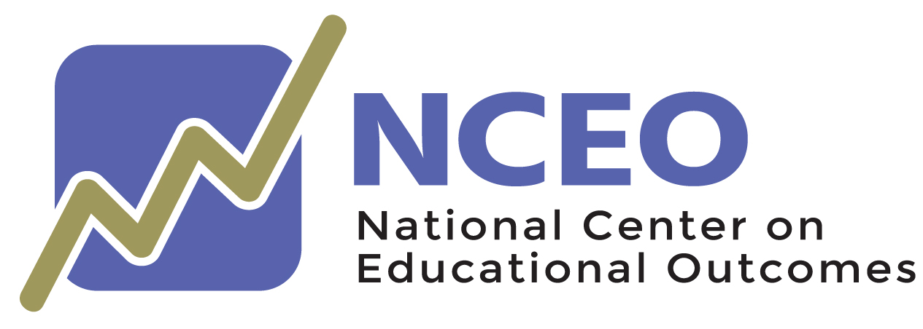

Communicating about Annual State Assessment Participation for All Students:
A Communication Toolkit—Photos

November, 2021

The Center is supported through a Cooperative Agreement (#H326G160001) with the Research to Practice Division, Office of Special Education Programs, U.S. Department of Education. The Center is affiliated with the Institute on Community Integration at the College of Education and Human Development, University of Minnesota. The contents of this report were developed under the Cooperative Agreement from the U.S. Department of Education, but does not necessarily represent the policy or opinions of the U.S. Department of Education or Offices within it. Readers should not assume endorsement by the federal government. Project Officer: David Egnor

The following photos are those included in NCEO’s publication, Communicating about Annual State Assessment Participation for All Students: A Communications Toolkit. They do not have a copyright and can be freely used in social media posts. To use, select “Save as Picture,” and save the image to your device.

