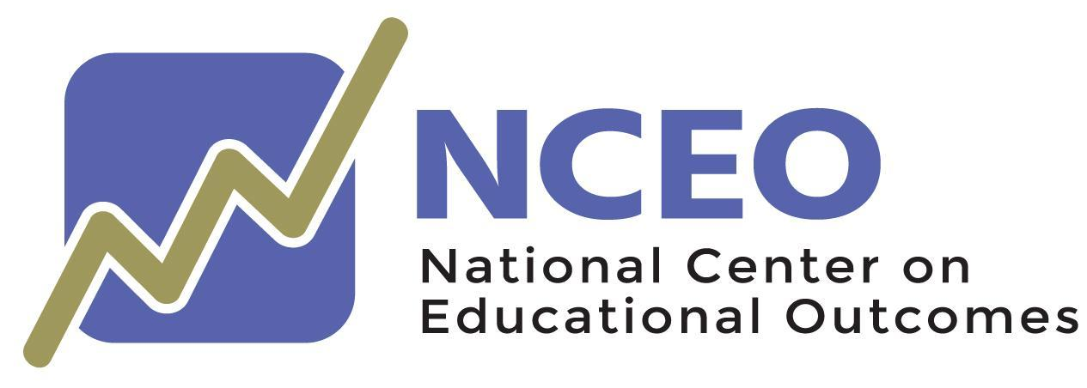

Empowering Families Toolkit

August 2023

Empowering Families Toolkit

A publication of
NATIONAL CENTER ON EDUCATIONAL OUTCOMES

Eliana Tardio, Kathy Strunk, Andrew R. Hinkle, and Sheryl S. Lazarus

Created in collaboration with NCEO’s 2022 Empowering Families to Understand the Role of Assessments in State Systemic Improvement Plans (SSIPs) Peer Learning Group (PLG)

The Center is supported through a Cooperative Agreement (#H326G210002) with the Research to Practice Division, Office of Special Education Programs, U.S. Department of Education. The Center is affiliated with the Institute on Community Integration at the College of Education and Human Development, University of Minnesota. Consistent with EDGAR §75.62, the contents of this report were developed under the Cooperative Agreement from the U.S. Department of Education, but do not necessarily represent the policy or opinions of the U.S. Department of Education or Offices within it. Readers should not assume endorsement by the federal government. Project Officer: David Egnor

All rights reserved. Any or all portions of this document may be reproduced and distributed without prior permission, provided the source is cited as:

Tardio, E., Strunk, K., Hinkle, A. R., & Lazarus, S. S. (2023). Empowering families to understand the role of assessments in State Systemic Improvement Plans (SSIPs) toolkit. National Center on Educational Outcomes.

Acknowledgments
This resource was developed through a collaborative process with the National Center on Educational Outcomes (NCEO) and the 17 states participating in NCEO’s 2022 Empowering Families to Understand the Role of Assessments in State Systemic Improvement Plans (SSIPs) Peer Learning Group (PLG), also called the Empowering Families PLG. The PLG met six times during September, October, and November 2022. The PLG was established to provide an opportunity for state education agency (SEA) staff and state parent and training information center staff to collectively identify activities that would increase parent participation and engagement in SEAs’ State Systemic Improvement Plan (SSIP) stakeholder planning meetings in states with an assessment-related State-Identified Measurable Result (SIMR). The resources in this toolkit are based on the content of the PLG and were developed collaboratively by the PLG participants and NCEO.
Participants in the Empowering Family PLG believed that empowering parents and families to understand the role of assessments in SSIPs is a significant commitment that requires collaboration between SEAs and parent representatives, such as parent centers and community parent resource centers. PLG participants said that families are eager to learn and actively participate in every aspect of their children's education; however, they need easy-to-understand and easy-to-access information. They also need to learn how to ask questions and bring suggestions when they participate in stakeholder meetings. This resource strives to help meet these needs.
The states participating in the Empowering Families PLG are listed here: Arizona, Colorado, Idaho, Illinois, Indiana, Maine, Michigan, Mississippi, Missouri, Nebraska, Oregon, Rhode Island, North Carolina, South Carolina, Tennessee, Wisconsin, and Wyoming. NCEO wishes to thank all participants for their contributions to this toolkit.

Empowering Families Toolkit

State education agencies (SEAs) are required to report information and data annually to the U.S. Department of Education’s Office of Special Education Programs (OSEP). This information is included in the State Performance Plan (SPP) and the Annual Performance Report (APR). There are 17 “indicators” or areas that must be addressed in the SPP/APR, such as the participation and performance of students with Individual Education Programs (IEPs) in statewide assessments, the education environments of students with IEPs (e.g., percent time in regular classroom, percent in a separate setting), and details about how the state’s systems and activities are designed to drive improved results for students with disabilities. Details about state-designed systems and activities for improved results for students with disabilities are included in the State Systemic Improvement Plan (SSIP), which is one of the 17 indicators. The SSIP is supposed to be a comprehensive, ambitious, yet achievable multi-year plan (i.e., 6-year plan) for improving results for students with disabilities. The plan requires components such as data analysis, infrastructure analysis, implementation, and evaluation. SSIP processes include gathering baseline data, setting targets for improved outcomes for each of the six years, and reporting updated data. The SSIP includes a State-Identified Measurable Result (SIMR) focused on student outcomes that states commit to reaching. Many states have assessment-related SIMRs.

In their SSIP, states must also describe the participation and engagement of multiple stakeholders in SSIP planning and activities. These stakeholders help inform the identification of the SIMR and the selection of the targets. The stakeholders also must be included in development, implementation, evaluation, and revision of the SSIP. In their SSIP, states must describe the specific strategies implemented to engage stakeholders in key improvement efforts and how the state addressed concerns, if any, raised by stakeholders.

Families of students with disabilities are an essential stakeholder group. In their SSIP, each state must describe how they meaningfully engaged families in the process. They are also required to report the number of parents who were members of the state’s SSIP stakeholder group. Additionally, they must describe activities they conducted to increase the capacity of diverse groups of parents to support the development of implementation activities designed to improve outcomes for students with disabilities.

Toolkit Overview

The purpose of this toolkit is to provide accessible materials for parents about topics related to assessment-related SSIPs and SIMRs. These materials are designed to help support their participation in stakeholder meetings. The toolkit includes short video clips and printed flyers. The materials are designed for dissemination through social media, state websites, and at meetings.

For each of four topics, the toolkit includes one to three short video clips and a printed flyer:

- Why are assessments important, and why should students with disabilities participate in assessments?
- What are the purposes of different kinds of tests, and how are they used in the SSIP?
- What is the SSIP and why do it?
- Understanding test data at SSIP stakeholder meetings

The video clips are each less than three minutes long and respond to the ongoing trend of keeping information interactive, highly visual, sharp, and appealing. These videos feature diverse populations in a variety of roles (e.g., educators, stakeholders, families) and settings (e.g., school meetings, classrooms). The videos include voice-over, captions, and scripts to help ensure they are accessible to diverse audiences. The videos are posted on YouTube and can be translated into different languages through the accessibility features of that platform.

The printable flyers are short one-page flyers that provide information in easy-to-understand language. The flyers are 508 accessible and can be read with assistive technology devices.

The toolkit also includes sample social media posts for each of the four topics. Social media can amplify and maximize potential reach through the delivery of information in accessible, engaging, friendly, easy-to-digest ways that promote the inclusion of all interested parties. SEAs, districts, and schools can use social media to build meaningful online communities that include families, educators, policymakers, and students who are knowledgeable of assessments and SSIPs.

Users may personalize or modify the social media post examples to match their state’s, district’s, or school’s voice, style, and interests. Depending on the social media platform used, the use of images and short videos can strengthen the message and provide opportunities to create meaningful and authentic connections with education partners.

To maximize the potential of social media, it is important to use customized hashtags in a consistent manner across the multiple social media platforms. Customized hashtags allow the user to search for all posts that have the same hashtag, and also allow users to look at performance metrics for the posts. Users are encouraged to use their own personalized hashtags to measure their own influence. For example, NCEO uses #NCEOInfo.

To access downloadable photos to use with social media posts, see https://nceo.umn.edu/docs/OnlinePubs/ParticipationCommunicationToolkit/CommunicationToolkitPhotos.docx. These photos can be freely used and do not need to be attributed.

Empowering Families Toolkit Content

Tool 1: Why are assessments important, and why should students with disabilities participate in assessments?

These resources are designed to help families understand why assessments are a good opportunity for their children to show what they know, and for schools to better understand their children’s needs. It also includes tips for families on how to better support their children when they take assessments. Versions 1 and 2 have the same script and voice recording but use different visuals. Version 1 uses professionally created video and version 2 contains an authentic video of a parent and her children. Version 2 in Spanish is the same video as version 2, but recorded in Spanish.

Sample Social Media Post. Assessments are a very important part of instruction for students, teachers, and families. When parents talk to their children about testing in a positive and motivating way, they can help them get excited to share what they know in important ways that will influence instruction and learning.

Video (Version 1) (professionally recorded video) downloadable at: https://www.youtube.com/watch?v=hyWs_aVakmo&t=32s
Video (Version 2) (authentic video of a parent and her children) downloadable at: https://www.youtube.com/watch?v=u_OIynZz2iA&t=5s
Video (Version 2 in Spanish) downloadable at: https://www.youtube.com/watch?v=bzlecGkuU5g

Flyer downloadable at: https://nceo.umn.edu/docs/PLG/EmpoweringFamiliesFlyer1.pdf

Tool 2: What are the purposes of different tests, and how are they used in the SSIP?

These resources define the different types of tests and their objectives. It describes various test purposes, and their role in improving instruction and outcomes for all students.

Sample Social Media Post. Different tests have different, and sometimes multiple, purposes that are used to inform decision making and improve instruction for all students, including students with disabilities. Learn here why it is so important for your child to participate!

Video downloadable at: https://www.youtube.com/watch?v=6a20g334P8M

Flyer downloadable at: https://nceo.umn.edu/docs/PLG/EmpoweringFamiliesFlyer2.pdf

Tool 3: What is the SSIP, and why do it?

These resources provide a family-friendly definition of the SSIP as it explains how states, educators, and families can work together to ensure their SSIP addresses the needs of students with disabilities in order to improve their educational outcomes.

Sample Social Media Post. What is the SSIP, or #SSIP, and how can states, educators, and families work together to achieve the best possible outcomes for students with disabilities? This product, created in collaboration with state education agencies and parent centers, can help.

Video downloadable at: https://www.youtube.com/watch?v=XubAnQ9uRvA

Flyer downloadable at: https://nceo.umn.edu/docs/PLG/EmpoweringFamiliesFlyer3.pdf

Tool 4: Understanding Test Data at SSIP Stakeholder Meetings

These resources explain how the review of test data at SSIP stakeholder meetings by parents and other stakeholders can support the development and implementation of plans that lead to improved outcomes for their children and all students with disabilities.

Sample Social Media Post. As the parent of a student with disabilities, do you know how your involvement in stakeholder meetings can support decisions that influence positive outcomes for your child? Learn more about your State Systemic Improvement Plan and how to get involved.

Video downloadable at: https://www.youtube.com/watch?v=FJuqVN8y4mA

Flyer downloadable at: https://nceo.umn.edu/docs/PLG/EmpoweringFamiliesFlyer4.pdf

