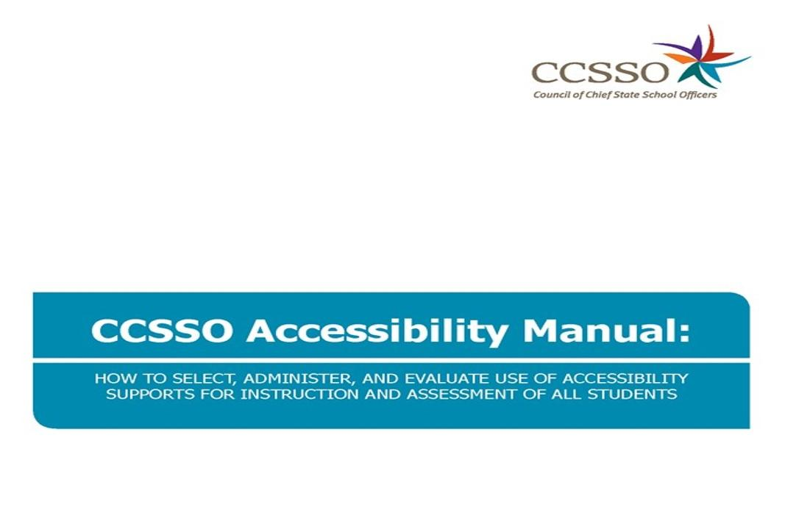
CCSSO ACCESSIBILITY MANUAL:
HOW TO SELECT, ADMINISTER, AND EVALUATE USE OF ACCESSIBILITY SUPPORTS
FOR INSTRUCTION AND ASSESSMENT OF ALL STUDENTS

COUNCIL OF CHIEF STATE SCHOOL OFFICERS
The Council of Chief State School Officers (CCSSO) is a nonpartisan, nationwide, nonprofit organization of public officials who head departments of elementary and secondary education in the states, the District of Columbia,
the Department of Defense Education Activity, Bureau of Indian Education, and five U.S. extra-state jurisdictions. CCSSO provides leadership, advocacy, and technical assistance on major educational issues.
The Council seeks member consensus on major educational issues and expresses their views to
civic and professional organizations, federal agencies, Congress, and the public.

Matthew Blomstedt (Nebraska), President
Carissa Moffat Miller, Chief Executive Officer

We are grateful to the
Assessment, Standards, and Education for Students with Disabilities (ASES) Collaborative
and the English Learners (EL) Collaborative for their help in creating this manual.

Authors:
Sheryl Lazarus, Linda Goldstone, Toni Wheeler, Jennifer Paul, Sharon Prestridge,
Tania Sharp, Angela Hochstetter, and Sandra Warren

The authors would like to acknowledge the CCSSO Students with Disabilities Task Force
and the CCSSO English Language Learners Task Force members for their collaboration on this manual.
The authors would also like to thank Virginia Ressa and Christopher Rogers for their assistance with editing and graphics.

Council of Chief State School Officers
One Massachusetts Avenue, NW, Suite 700
Washington, DC 20001-1431
Phone (202) 336-7000
Fax (202) 408-8072
www.ccsso.org

© 2021 by the Council of Chief State School Officers, (CCSSO Accessibility Manual: How to Select, Administer, and Evaluate Use of Accessibility Supports for Instruction and Assessment of All Students), except where otherwise noted, is licensed under a Creative Commons Attribution 4.0 International License http://creativecommons.org/licenses/by/4.0 it is available at www.ccsso.org.

NOTE: If adapting any of this report, please include the following attribution:
This document is an adaptation of the following National Center on Educational Outcomes report commissioned and published by CCSSO: Lazarus, S., Goldstone, L., Wheeler, T., Paul, J., Prestridge, S., Sharp, T., Hochstetter, A., and Warren, S. (2021). CCSSO Accessibility Manual: How to Select, Administer, and Evaluate Use of Accessibility Supports for Instruction and Assessment of All Students. The Council of Chief State School Officers (CCSSO).

.Table of Contents

CCSSO Accessibility Manual: How to Select, Administer, and Evaluate Use of Accessibility Supports for Instruction and Assessment of All Students

Structure of This Document 4
Section I: Background 5
Intended Audience and Recommended Use 6
Recognizing Accessibility Needs for All Students 9
Section II: Three-Tiered Approach to Accessibility 11
Universal Features 11
Making Decisions About Universal Features 11
Designated Features 11
Making Decisions About Designated Features 12
Accommodations 12
Making Decisions About Accommodations 12
Section III: The Five-Step Decision-Making Process 14
Step 1: Expect Students to Achieve Grade-Level Standards 14
Including All Students in State Assessment Systems 15
Federal and State Laws, Legal Cases, and Federal Guidance Requiring Student Participation 16
Equal Access to Grade-Level Content 16
Current Practice and Beyond 16
Step 2: Learn About Accessibility Supports for Instruction and Assessment 17
Universal Design Implications 19
Administrative Considerations for Instruction and Assessment 19
Modifications in Instruction and Assessment 20
Instructional Accessibility Supports 21
Step 3: Select Accessibility Supports for Instruction and Assessment 23
Documenting Accessibility Supports for All Students 23
Decision-Making Process 24
Accessibility Selection 24
Involving Students in Selecting, Using, and Evaluating Accessibility Supports 26
Prior Use of Accessibility Supports 27
Accessibility Supports for Instruction and Assessment 27
Valid Measure of What the Student Knows and Can Do 28
Step 4: Administer Accessibility Supports During Instruction and Assessment 29
Accessibility During Instruction 29
Accessibility During Assessment 29
Ethical Testing Practices 30
Standardization 30
Step 5: Evaluate Use of Accessibility Supports in Instruction and Assessment 31
Post-Secondary Implications 31
Tools 33
Tool 1: Three-Tiered Approach to Accessibility 33
Tool 2: Questions to Ask When Selecting Accessibility Supports 34
Tool 3: Accessibility Supports from the Student’s Perspective 36
Tool 4: Parent and Guardian Input on Accessibility 38
Tool 5: Accessibility Selection Questions for Teams 40
Tool 6: Accessibility Supports in the Classroom: Questions for Teams 43
Tool 7: After-Test Accessibility Questions for Teacher-Student Discussion 45
Tool 8: Questions to Guide Evaluation of the Use of Accessibility Supports at the School or District Level 46
Tool 9: Questions to Guide Formative Evaluation at the Student Level 48
Tool 10: Team Evaluation of Classroom Accessibility Features and Accommodations 49
Other Comments: 49
Tool 11: Five-Step Decision-Making Process 50
Appendices 51
Appendix A: Federal Laws 51
Documenting Accessibility Supports Under the Individuals with Disabilities Education Act (IDEA) 51
Documenting Accessibility Supports on a Student’s 504 Plan 51
Federal Laws, Legal Cases, and Federal Guidance on Student Participation 53
Appendix B: Universal Features 60
Embedded Universal Features Available to All Students 60
Non-Embedded Universal Features Available to All Students 62
Appendix C: Designated Features 64
Embedded Designated Features Identified in Advance 64
Non-Embedded Designated Features Identified in Advance 65
Appendix D: Accommodations 69
Embedded Accommodations Available with an IEP or 504 Plan 69
Non-Embedded Accommodations Available with an IEP or 504 Plan 71
Appendix E: Glossary of Terms and Acronyms 75

Structure of This Document

- Section I: Background
- Section II: The Three-Tiered Approach to Accessibility
- Section III: The Five-Step Decision-Making Process
- Tools: Tools that educational stakeholders can use to make instructional and assessment content more accessible for all students
- Appendices: Details on federal laws, universal features, designated features, accommodations, and glossary of terms and acronyms

Bolded words indicate that the term is included in the Glossary (Appendix E). Similarly, bolded tool numbers and appendices’ titles indicate that these items are found in the Tools or Appendices near the end of the document.

Section I: Background

The Council of Chief State School Officers (CCSSO) Accessibility Manual: How to Select, Administer, and Evaluate Use of Accessibility Supports for Instruction and Assessment of All Students establishes guidelines for states to use for the selection, administration, and evaluation of accessibility supports for instruction and assessment of all students, including students with disabilities, English learners (ELs), ELs with disabilities, and students without an identified disability or EL status.
Accessibility supports discussed herein include both embedded (digitally-provided) and non-embedded (non-digitally or locally provided) universal features that are available to all students as they access instructional or assessment content, designated features that are available for those students for whom the need has been identified by an informed educator or team of educators, and accommodations that are generally available for students for whom there is documentation on an Individualized Education Program (IEP), Section 504, or EL Plan. Approaches to these supports may vary, depending on state or assessment contexts as well as nature of assessments.
This resource serves state education agency (SEA) leaders in several ways, and it can be used as a customizable base for or extension of education-accessibility manuals. The manual does not establish specific accessibility policies, but rather summarizes the current body of knowledge on accessibility supports. It highlights the Five-Step Decision-Making process, along with tools for effectively selecting, administering, and evaluating accessibility features and accommodations.
Shaded gray boxes indicate areas where states may want to add state-specific information. Additionally, SEA leaders might choose to customize tools and appendices, including the accessibility framework (Tool 1) to make it state-specific. Depending on audiences and purposes of application, states might choose to use this manual as a whole, or employ various sections and tools separately (e.g., for targeted professional development purposes).
New policy and implementation issues often arise regarding accessibility supports for all students, necessitating updates to states’ accessibility policies. Users of this manual are encouraged to review and revise their customized version of this document on an ongoing basis.
There is a glossary at the end of the manual which defines many words. All words which are defined in this manual contain links to the glossary. Users may refer to the glossary for definitions of terms used, as intended for the purposes of this manual. However, individual states may have differing definitions of each of the student groups referenced in this manual (i.e., general education students, students with disabilities, ELs, and ELs with disabilities), and state leaders may want to customize it to make it state-specific.

The CCSSO Accessibility Manual: How to Select, Administer, and Evaluate Use of Accessibility Supports for Instruction and Assessment of All Students represents the most current understanding of best practices up to the point of publication. As understanding and research continue to grow around the effective education of all students, this resource will be updated to address relevant new developments.

Intended Audience and Recommended Use

The CCSSO Accessibility Manual: How to Select, Administer, and Evaluate Use of Accessibility Supports for Instruction and Assessment of All Students is helpful for:
- general education, English Learner (EL), and special education teachers (e.g., to find and evaluate instructional and assessment supports for their students);
- school and test administrators and related services personnel (e.g., to support selection and administration of assessment accessibility supports for each student);
- assessment staff, administrators (e.g., to provide guidance for teachers, test administrators, etc. on options and limitations around specific accessibility supports); and
- parents and guardians (e.g., to serve as a tool when advocating for accessibility supports and review processes for their children).

This resource emphasizes an individualized approach to the implementation of accessibility practices. It recognizes the critical connection between accessibility supports (features and accommodations) in instruction and during assessments, as well as the iterative nature of reevaluating decisions for more informed decision-making as contexts and student needs evolve.

The manual presents a three-tier accessibility framework (See Figure 1, Tool 1) of universal features, designated features, and accommodations, with the understanding that states and other entities may employ different terms for these three tiers (see Appendices B, C, and D) or may add a fourth tier of administrative considerations which lists practices that are often included in test-administration manuals (e.g., minimizing distractions). Moreover, what is considered in each tier may differ from one state to another; states can adapt or adopt the framework as needed (See Tool 1). It is important to keep in mind that the same accessibility supports may be considered universal in one assessment but designated as an accommodation in another. This difference usually depends on the construct which is the focus of a particular assessment or instruction. For example, on an English language proficiency (ELP) assessment, some test items for all ELs might contain a text-to-speech support. Thus, what might be a specific EL support on a content assessment might be part of the default test format on an ELP assessment. Additionally, some accessibility supports which are allowable on content assessments may be prohibited on ELP or alternate assessments, or vice versa.

This manual also includes considerations for students who participate in alternate assessments, to assist educators with the process of including this population of students in meaningful educational experiences. The framework provides a general understanding of the accessibility supports educators will need to have in place for both instruction and assessment for students who take alternate assessments.

Figure 1. Three-Tier Accessibility Framework

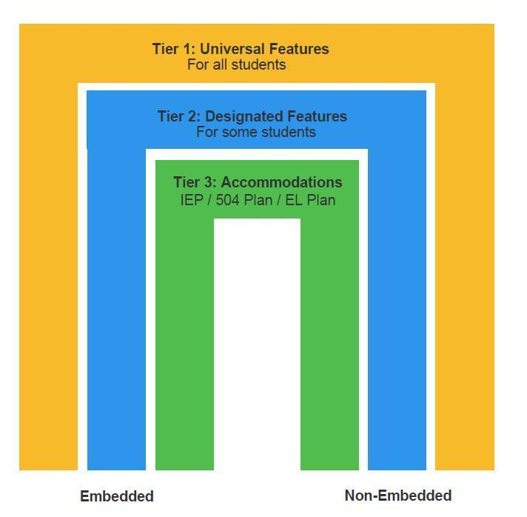

This manual outlines The Five-Step Decision-Making Process for administering accessibility supports. Figure 2 highlights the five steps of the process.

Figure 2. Five-Step Decision-Making Process for Administering Accessibility Supports
= 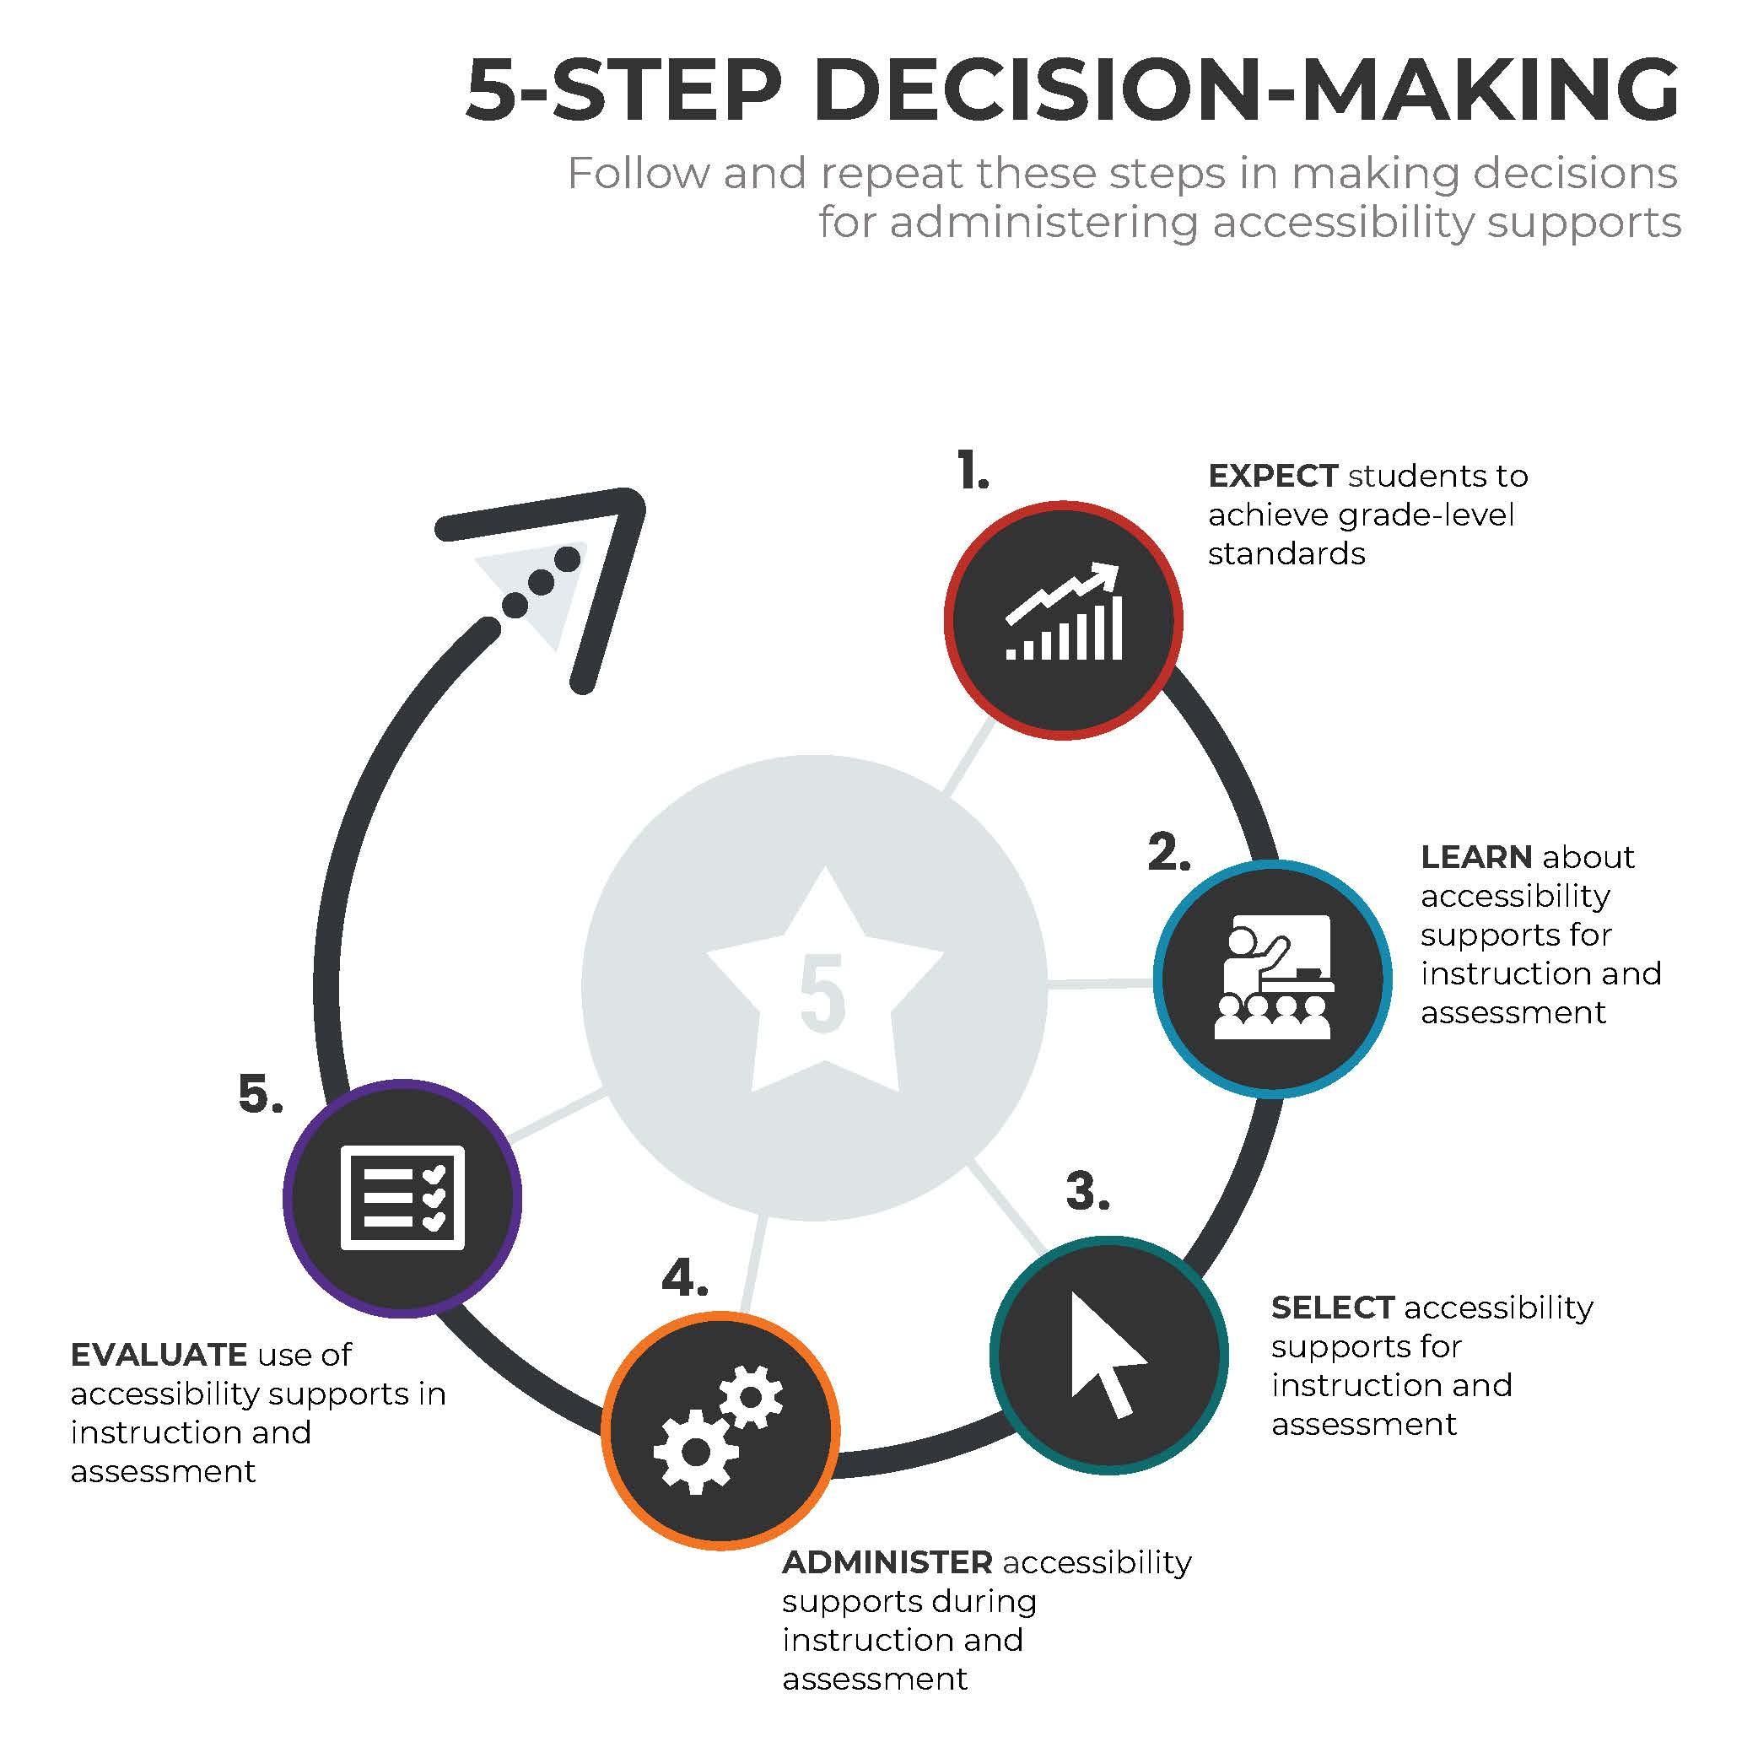

Recognizing Accessibility Needs for All Students

In the context of new, technology-based instruction and assessments, a range of accessibility supports are available to meet individual student needs and preferences. These individualized supports place greater responsibility on educator teams and individuals to make informed decisions about which students need and should receive specific supports, factoring in a variety of accessibility choices. Even those features that are universally available for all students may need to be turned off for some students if they prove to be distracting. (For example, a specific student may find a zoom feature that alternates between magnifying and reducing the size of text and graphics distracting.) Educators need to ensure that students have ample opportunity to practice using the accessibility supports and features that will be available to them during assessments. Note that accommodation policies for non-state run assessments are often developed by the test’s publisher, and users must adhere to the publisher’s administration and accommodation policies.

TO CUSTOMIZE THIS MANUAL, INSERT IN THIS BOX
(OR DELETE):

NON-STATE RUN ASSESSMENTS, WITH LINKS TO THOSE TEST ADMINISTRATION AND ACCOMMODATION POLICIES.

Section II: Three-Tiered Approach to Accessibility

This section highlights the Three-Tiered Approach to Accessibility currently employed by many states: universal features, designated features, and accommodations. Educators should be mindful that other terms sometimes are used to describe these three tiers (e.g., universal tools, features for all students). See Tool 2, universal features (Appendix B), designated features (Appendix C), and accommodations (Appendix D) used in some states. It is important to note that certain accessibility supports may belong to different tiers or may be prohibited, depending on state policies and instructional/assessment implications. States may customize the framework in ways that align with their approach (See Tool 1).

Universal Features

Universal features are accessibility supports that are available to all students as they access instructional or assessment content. They are either embedded and provided digitally through instructional or assessment technology (e.g., answer-choice eliminator), or non-embedded and provided non-digitally at the local level (e.g., scratch paper). Appendix B includes universal features currently used in some states along with their descriptions and recommended uses.

Making Decisions About Universal Features

Although universal features are available to all students, some educators and students may determine that one or more of the features are distracting; if so, there should be a way to request that the distracting features be turned off. Educators also need to make sure that appropriate, non-embedded universal features are available to meet individual students’ needs.

Designated Features

Designated features are available for use by any student for whom the need has been indicated by an educator (or team of educators, including the parents or guardians and the student, if appropriate). The people who identify a need for designated features are those who are familiar with the student. Embedded designated features (e.g., a dictionary) are provided digitally through instructional or assessment technology, while non-embedded designated features (e.g., an abacus) are provided locally. Designated features must be assigned using a consistent process. Appendix C includes designated features currently used in some states, along with their descriptions and recommended uses.

Making Decisions About Designated Features

As noted, decisions about designated features should be made by educators and teams who are familiar with the child’s characteristics and needs — such as those who are involved in the student’s Individualized Education Program (IEP), 504, or EL team —including the student’s parents or guardians, as well as the student, as appropriate. The Five-Step Decision-Making Process is a helpful tool, and it will help all who are involved to make appropriate decisions regarding specific accessibility supports the student will need and use during instruction and assessments.

State leaders also might use planning tools, such as a Personal Needs Profile (PNP), or similar systems to document which designated features (and accommodations, if applicable) need to be made available for designated students.

Accommodations

Accommodations are changes in procedures or materials which (a) ensure that a student has equitable access to instructional and assessment content and (b) support valid assessment results for those students who require them. Accommodations are available in all states for students whose IEP or Section 504 plan outlines the need for them. Some states also offer accommodations for ELs. It is important to note that accommodations do not reduce expectations for learning. Embedded accommodations (e.g., closed captioning) are provided digitally through instructional or assessment technology, while non-embedded accommodations (e.g., a scribe) are provided locally. Appendix D includes accommodations currently used in some states as well as descriptions and recommendations for use.

Making Decisions About Accommodations

Educators on a student’s 504, IEP, and/or EL team, along with the student’s parents or guardians and the student (if appropriate) make decisions regarding needed accommodations. For ELs with disabilities, for example, members of all teams collaborate to (a) provide evidence of the student’s need(s) for accommodations and (b) make sure those needs are noted on the student’s IEP, EL plan, and/or 504 plan. A representative from each team should enter information regarding accessibility features and accommodations from the relevant plan (i.e., IEP, 504, or EL) into a shared, consolidated planning tool (e.g., ISAAP, PNP). This approach will ensure that all needed features and accommodations can be effectively activated for the student. See Tool 2 for an inventory of the accommodations which are available in your state.

Decisions about tools, supports, and accommodations should be integrated into all district, school, and/or classroom processes which prioritize student needs and ensure equity of accessibility for all students.

Section III: The Five-Step Decision-Making Process

This section describes a five-step process that can be used to make optimal accessibility decisions for students who need accessibility supports for instruction and assessment:

Step 1: EXPECT students to achieve grade-level standards.
Step 2: LEARN about accessibility supports for instruction and assessment.
Step 3: SELECT accessibility supports for instruction and assessment.
Step 4: ADMINISTER accessibility supports during instruction and assessment.
Step 5: EVALUATE use of accessibility supports in instruction and assessment.

Step 1: Expect Students to Achieve Grade-Level Standards

Academic standards are educational targets outlining what all students are expected to master at each grade level. The expectation that students will achieve grade-level standards is reiterated in laws, legal cases, and federal guidelines that require states to administer assessments to all students; these measures are intended to hold schools accountable for the academic performance of all their students. To provide equal access to grade-level content, some students are given accessibility supports during instruction and assessment.

Individual educators or teams of educators who are familiar with characteristics and needs of students, along with the students’ parents or guardians (and the students themselves, as appropriate), should make instructional and assessment decisions that prioritize access to grade-level content. Educators are responsible for developing, implementing, and improving accessibility practices for students. Educators serving in the following roles may be involved in making accessibility decisions:

- special education teachers, IEP or 504 plan committee representatives, and related service providers;
- English language educators and facilitators;
- assessment officials (test administrators, test coordinators, guidance counselors);
- general education teachers (classroom/content teachers); and
- school administrators (principals, school/district officials).

To accomplish the goal of equal access in education, every educator must:

- know and instruct grade-level standards;
- be familiar with individual student needs and supports to provide access;
- collaborate with other educators, stakeholders, and parents or guardians for successful student access; and
- be familiar with accountability systems at both the state and district levels.

All students work toward mastery of grade-level standards, including English-language proficiency, and should be expected to achieve these standards — provided that the following conditions are met:

1. Collaboration between special education teachers, English language teachers, and general education teachers results in grade-level, differentiated instruction for the diverse/specific populations of students they are serving.
2. Individualized approaches to instruction and assessment are used, and individualized plans are developed and implemented for those students who need them.
3. Appropriate accessibility supports are provided to ensure that all students can access instructional and assessment content.

Including All Students in State Assessment Systems

Federal law and guidance, legal cases, and most state laws require that all students be administered assessments which are intended to hold schools accountable for the academic performance of their students. Educators are expected to actively engage in a planning process that addresses:

- implementation of accessibility supports to facilitate universal student access to grade-level instruction and assessments;
- use of alternate assessments to assess achievement of those students with the most significant cognitive disabilities;
- equitable access to grade-level instruction and English language development services for all EL students; and
- inclusion of ELs in both academic and English language proficiency assessments.

Federal and State Laws, Legal Cases, and Federal Guidance Requiring Student Participation

To effectively support all students in the classroom, educators should be familiar with federal and state laws, current guidelines, and legal cases that regulate student participation in the educational processes. Several important laws require the participation of these students in standards-based instruction and assessment. Some laws solely address students with disabilities (e.g., Individuals with Disabilities Education Act – IDEA); others regulate educational policies and practices for all students (e.g., Elementary and Secondary Education Act – ESEA). Some laws or sections of laws are devoted to ELs (e.g., Title III of ESEA). Both sets of laws affect the instruction and assessment of ELs with disabilities. Appendix A highlights federal laws, legal cases, and federal guidance regulating student participation in educational processes.

Equal Access to Grade-Level Content

It is important for all educators to be familiar with current standards and accountability systems, at both the district and state levels. This knowledge frames a context in which educators are required by law to make sure that all students, including students with disabilities, ELs, and ELs with disabilities, work toward grade-level academic content standards; for ELs, this means maintaining grade-level work while also improving their English-language proficiency. The goal is to provide meaningful, differentiated instruction of grade-level content for diverse students by selecting appropriate accommodations and fostering continual collaboration between EL/special education educators and their general education counterparts.

To aid the goal of providing equal access to grade-level content, accessibility supports and accommodations must be provided for students during both instruction and assessments. Accommodations should be used consistently for a reasonable length of time prior to use on state assessments. Only supports utilized throughout instruction should be selected for use in assessments.

Current Practice and Beyond

Supported by ongoing educational reform efforts passed by states, assessments for accountability purposes likely will continue well into the future.

Step 2: Learn About Accessibility Supports for Instruction and Assessment

With the evolving use of technology in instruction and assessment, it is important to be aware of the possible impact of new technological developments on the provision of educational supports. Educators are encouraged to:

- Find and review your state’s policies about appropriate use of supports during assessments.
- Understand the application of universal design principles to instruction and assessment.
- Find and review your state's policies on administrative considerations for state assessments.

Thanks to advances in technology, computer-based accessibility supports can be used to facilitate individualized educational processes by reducing or eliminating the effects of a students’ disabilities— thereby enabling them to more effectively demonstrate what they know and can do. For example, when the instructional objective is focused on comprehension, appropriate supports for a student with a reading disability might include reading the material aloud or letting the student use a text-to-speech app to access grade-level content. However, read-aloud or text-to-speech supports would not be appropriate when the learning target is decoding text. Accessibility supports provided in the classroom do not reduce expectations for learning. Accessibility supports empower students with a multitude of choices, enabling them to effectively access instructional and assessment content.

As noted above, accessibility supports provided during state assessments must also be provided during classroom instruction, classroom assessments, and district assessments. However, some instructional accessibility supports may not be appropriate for use on certain statewide assessments. In other cases, accessibility supports provided on assessments may be slightly different from those provided in the classroom (e.g., digital note-taking on an assessment), since the technology used for the assessment may differ from that used in the classroom. It is important that educators help students become familiar with the supports provided on the assessment, so students are not using these tools for the first time on test day.

It is critical for educators to be familiar with state policies about the appropriate use of accessibility supports during assessments. In the age of technology-mediated educational practices, accessibility supports facilitate instruction and assessment of students effectively – but only when they are appropriately selected, used, and evaluated for continued effectiveness.

For some students, use of accessibility supports may not begin and end in the school setting. For instance, they might utilize similar supports in the library or at home to read or complete homework. As students become more proficient in grade-level content areas and/or English proficiency, their need for some supports may decrease. However, all accessibility supports for instruction and assessment are integrally intertwined and should be treated as such.

When determining accessibility supports for state assessments, it is important to remember that ELP, content area, and alternate assessments measure different construct knowledge, skills, and abilities. For example, a math content area assessment may allow for translation into another language, but an English language proficiency assessment may not. Therefore, different accessibility supports may be necessary for each assessment. To stay informed, educators are encouraged to regularly research new and existing accessibility support options.

TO CUSTOMIZE THIS MANUAL, INSERT IN THIS BOX
(OR DELETE):

CURRENT STATE POLICIES REGARDING
WHERE TO DOCUMENT A STUDENT’S ACCESSIBILITY SUPPORTS

The key to effective and equitable instruction and assessment is meaningful collaboration around instruction and accessibility supports among classroom teachers, special education teachers, EL teachers, school administrators, assessment officials, parents or guardians, and students.

Universal Design Implications

Universal design principles improve access to instruction and assessments for all students. Some instructional and assessment formats may inhibit the ability of some students to fully participate and demonstrate what they know and can do. Universal design principles help resolve this dilemma. In contrast to retrofitting, these principles are meant to be applied and integrated consistently during the initial phase of planning and developing accessible instructional and assessment materials:
- inclusion of diverse student populations;
- precisely defined instructional and assessment constructs;
- maximally accessible, non-biased content;
- compatibility with accommodations;
- simple, clear, and intuitive instructions and procedures; and
- maximum readability, comprehensibility, and legibility.

Universal design is not synonymous with computer-based instruction or online assessments. However, as technology improves, options for universal design are likely to also advance. Traditionally, universal design comes first, and accommodations are applied as needed during instruction and assessment. Today, some accommodations are embedded into the design and may be included in the online delivery of instructional and assessment content. This dynamic allows for more universal or designated features to be made available to more students as accessibility options.

Administrative Considerations for Instruction and Assessment

Some administrative resources and strategies, such as scheduling instruction and testing at times that are most beneficial to the student, should be available for all students. For this reason, some states do not classify these supports as accessibility features or accommodations, while other states classify some (e.g., breaks) as universal features. These administrative considerations, which are often addressed in a test administration manual, should be used for all students, whenever possible.

TO CUSTOMIZE THIS MANUAL, INSERT IN THIS BOX
(OR DELETE):

CURRENT STATE POLICY ON ADMINISTRATIVE CONSIDERATIONS

Modifications in Instruction and Assessment

Accessibility supports meet students’ specific needs and enable their work to be a more valid measure of what the students know and can do. Accessibility supports do not reduce or change learning expectations or standards.

Modifications refer to practices or materials that change, lower, or reduce state-required learning expectations. Modifications may change the underlying construct of an assessment. Examples of modifications include:

- requiring a student to learn less material (e.g., fewer objectives);
- reducing or revising assignments and assessments (e.g., complete only the easiest questions, remove some of the answer options);
- using an accessibility support that invalidates the intended construct; and
- giving a student hints or clues to the correct responses on assignments and assessments.

Providing modifications during classroom instruction and classroom assessments may reduce the student’s opportunities to learn critical content, creating unintended inequities. Nevertheless, if modifications are deemed necessary in instruction, students and parents or guardians must be made aware that these modifications will not be provided on the state assessments. It is important to emphasize: when students’ access to critical, assessed content is reduced, they are put at risk for not meeting state requirements.

Providing a modification during a state accountability assessment constitutes a test irregularity, invalidates test scores, and results in an investigation of the school’s or district’s testing practices by the state.

TO CUSTOMIZE THIS MANUAL, INSERT IN THIS BOX
(OR DELETE):

CURRENT STATE POLICY ON MODIFICATIONS AND TEST IRREGULARITIES

Instructional Accessibility Supports

In order to optimize students’ educational experiences, it is vital for educators to meet regularly to coordinate instructional approaches and familiarize themselves with state policies. Educators should consider:

- student characteristics and needs;
- criteria for the student to demonstrate grade-level proficiency of state standards; and
- consistency between accessibility supports for instruction and for assessments.

Four key questions for educators to ask:
- What are the student’s specific instructional and assessment needs?
- How does facilitating the student’s access to curriculum, instruction, and assessments support the goal of developing independence?
- Is there a universal feature the student should not have?
- Does the student need any designated features or accommodations?

These questions help educators to focus on students’ needs. For instance, a student may not be receiving enough accessibility supports — or may be receiving too many. More is not necessarily better. Providing students with unnecessary supports may negatively impact their performance. A better approach is to focus on the student’s identified needs within the general education curriculum.

One size does not fit all with accessibility supports. To ensure that all students are engaged in grade-level instruction, educators should consider individual needs and characteristics when making accessibility decisions. Supports for dually identified students should be approached with both their English-language needs and disability needs considered. For example, IEP team members for ELs with disabilities will need to make individualized accessibility decisions based on the specific language- and disability-related challenges faced by each student (See Figure 3). Moreover, it is critical to recognize that a student’s needs are not static but lie on a continuum; accessibility supports may change as a student’s English-language or disability-related needs change.

Figure 3. English Language- and Disability-Related Needs Affecting Accessibility Decisions
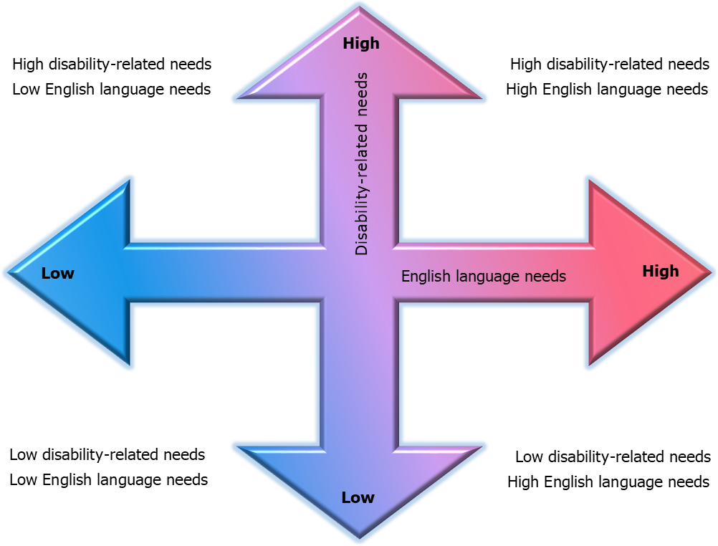

Categories included in this figure are based on Shyyan, Christensen, Touchette, Lightborne, Gholson, and Burton, 2013. Accommodations manual: How to select, administer, and evaluate use of accommodations for instruction and assessment of English language learners with disabilities. Washington, DC: CCSSO.

This approach aims to reiterate that educators should fully account for the complexity of both language and disability implications during the instruction and assessment of ELs with disabilities.

TO CUSTOMIZE THIS MANUAL, INSERT IN THIS BOX
(OR DELETE):

- CURRENT STATE INFORMATION ON ENGLISH LANGUAGE PROFICIENCY LEVELS
- CURRENT STATE INFORMATION ON DISABILITY CLASSIFICATIONS
- IMPLICATIONS FOR THE HIGHLIGHTED APPROACH

Step 3: Select Accessibility Supports for Instruction and Assessment

Effective decision-making around the provision of appropriate accessibility supports begins with appropriate instructional decisions. In turn, optimal instructional decisions are facilitated by gathering and reviewing reliable information about the student’s access needs, disability, English language proficiency, and present level of performance in relation to state standards.

To promote all students’ meaningful and equitable participation in the general curriculum, educators need to select accessibility supports based on distinct, individual student characteristics. Making blanket decisions for groups of students at specific language acquisition levels or with specific disabilities is not appropriate. When individualized accessibility decisions are made thoughtfully, they can advance equitable opportunities for students to participate in the general education curriculum.

Students’ needs, characteristics, and even preferences are important criteria to consider when making optimal accessibility decisions. In addition, with regard to EL students, other criteria may help educators determine which accessibility supports are most appropriate – including (among others):
- literacy levels in the student’s native language;
- education received before coming to the U.S. (e.g., evidence of limited or interrupted formal education);
- time spent in English-speaking schools;
- resources available in the student’s native language; and
- student/family cultural background.

While it is important to research all accessibility support options, note that some options may not be allowed on certain assessments. For example, use of a glossary may be allowed for a math assessment but prohibited for an ELP assessment, since the support could alter the construct being tested, thereby invalidating the results.

Documenting Accessibility Supports for All Students

To ensure continuous monitoring and improvement of accessibility approaches, educators should both review notes from other educators and document how students use accessibility supports (Tools 2, 3, 4, 5, 6, 7, 8, 9, 10). They also should document which universal features (if any) are deactivated and which designated features/accommodations are available. This enables other educators to make more informed decisions based on longitudinal data. It is also important to use or create an after-test exit survey (e.g., Tool 7) to collect information on the use of accessibility supports; this data can be used to inform future decisions about instruction and assessment practices.

Decision-Making Process

There are many factors to consider when making decisions about providing accessibility supports — most importantly:

- Student characteristics (disabilities, language proficiency, previously used accessibility supports, student preferences, etc.).

- Student needs (what will enable the student to access state assessments):
  - the type of tasks required, so the teacher can replicate them in classroom instruction and on assessments; and
  - ways to remove barriers that inhibit a student’s ability to perform those tasks.

If multiple accessibility supports are employed for a student, educators should be aware of possible unintended consequences. For example, when using a highlighter, the color might change if the “contrast” function is activated, which could be challenging for vision-impaired students.

Accessibility Selection

Selection of accessibility supports for instruction should be based on the individual student’s characteristics and student needs (See Figure 4, below). It is important to implement the selected supports as planned by the team of educators. Assessment accessibility supports are based on instructional supports, as well as specific assessment policies. These work together to allow for a valid measure of what the student knows and can do.

Figure 4. Accessibility Selection

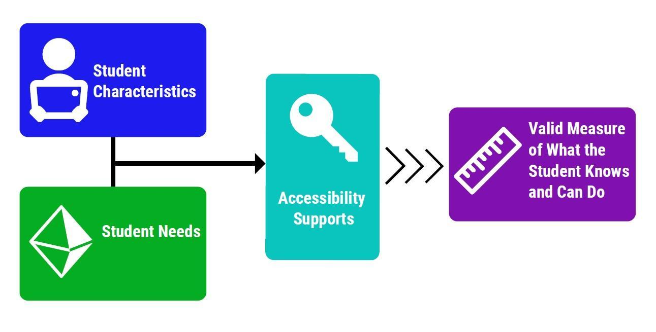
When matching accessibility supports with students’ characteristics, educators should consider:

- the student’s willingness to learn to use the accessibility support;
- opportunities to learn to use the accessibility support in classroom settings; and
- conditions for use on district and state assessments.

After considering student characteristics, it is important to examine student needs during instruction and testing, as well as the types of tasks students are asked to perform in the classroom and on state or district assessments. When matching accessibility supports with student needs, it is also key to consider how the support interacts with:

- the construct of the material for which the student will use the accessibility support;
- content exposure, with varying cognitive complexities and range of difficulty; and
- the opportunity to show mastery (according to achievement or performance-level descriptors for the assessment).

Tool 5 is a list of questions to guide the selection of appropriate accessibility supports –both for students being assigned the supports for the first time and for those already using them. These questions address student characteristics and needs that may influence which accessibility supports to consider for an individual student.

Involving Students in Selecting, Using, and Evaluating Accessibility Supports

It is critical that students come to understand their own needs and learn to self-advocate. Informing others of their preferences, particularly in the presence of “authority figures,” may be a new task for some students. By providing guidance and feedback in the context of selecting, using, and evaluating accessibility supports and their combinations, educators and parents or guardians play a key role in developing a student’s self-advocacy.

Student involvement in the selection process of their accessibility supports provides opportunities to learn self-advocacy skills and independence. Students need these opportunities to learn how to make certain the accessibility supports they need are provided, both in and out of school. Even students with significant cognitive disabilities, many of whom do not have sophisticated expressive communication systems, can show teachers their preferences. For example, when shown two versions of an accommodated graph, students could gesture to the one they like or understand better. It is important to not limit students’ options but rather expand their opportunities to provide feedback and self-advocate. This is especially important for those students who cannot communicate their preferences in traditional ways.

TO CUSTOMIZE THIS MANUAL, INSERT IN THIS BOX
(OR DELETE):

CURRENT STATE POLICY ON THE PROCESS
OF SELECTING ACCESSIBILITY SUPPORTS

Prior Use of Accessibility Supports

Students are most successful with accessibility supports when they have used the supports and are comfortable with them prior to the test. As noted, accessibility supports should not be used for the first time on a state test. Educators are encouraged to implement accessibility supports during instruction and local assessments, so students can become adept at using them before the state assessment is administered.

It is therefore important to plan time for students to investigate and become familiar with new accessibility supports and learn how to use and practice embedded and non-embedded accessibility supports. (Note that, for embedded supports, there may be tutorials and/or practice or sample exam items students can experience prior to test administration.) It is also valuable to build in time to evaluate the use of accessibility supports and make improvements as needed, both before and after the state assessment (Tools 6 and 7).

TO CUSTOMIZE THIS MANUAL, INSERT IN THIS BOX
(OR DELETE):

CURRENT STATE INFORMATION ABOUT ITEM AND OR TOOLS SAMPLERS

Accessibility Supports for Instruction and Assessment

On some assessments, accessibility supports may be presented differently from their variations used during instruction. Teachers should make sure students are informed about these differences and provide opportunities for them to practice the different accessibility supports prior to the test. This is particularly important for students with the most significant cognitive disabilities, who may need extra preparation prior to taking online assessments.

If the accessibility support is considered a necessary step in scaffolding grade-level content instruction, practicing classroom work without the support helps gauge student progress independent of the support. This provides students with opportunities to practice not using the support before the state assessment. If the instructional accessibility support is more permanent in nature and not permitted on a state or district assessment, the educator team will need to consider whether the accessibility support alters what the test is intended to measure.

Valid Measure of What the Student Knows and Can Do

When selecting accessibility supports for state assessments, it is important to understand the accessibility policies the state has established to maintain the validity of assessment results. It is also important to know the consequences of support-selection and use decisions. For example, if educators determine that a student should use an allowed accessibility support during an assessment but the student refuses to use the support, the student’s decision could compromise the validity of the measurement results about what the student knows and can do. Note that the validity implications for such decisions are different for ELP assessments than they might be for content assessments (i.e., providing a translation of the test content, versus providing a translation of test directions). Accessibility supports for ELs should be selected in accordance with whether the test is assessing language proficiency or content-area knowledge.

Consideration of longer-term consequences is important, as well. For example, as students begin to make post-secondary choices, the best accessibility supports may be those that help prepare them for their future as adults. The team (educators, parents or guardians, and students) may want to discuss whether their current accessibility decisions with regard to instruction and assessments might affect the student’s prospects for successful self-efficacy in the future. The team (educators, parents or guardians, and students) should plan how and when the student will learn to use each new accessibility support and ensure ample time for practice before an assessment takes place. They also should plan for an ongoing evaluation of the student’s use of accessibility features and, if applicable, how and when the student is to become independent of some or all supports.

The following tools provide additional information on this step.

Tool 2: Questions to Ask When Selecting Accessibility Supports
Tool 3: Accessibility Supports From the Student’s Perspective
Tool 4: Parent Input on Accessibility Supports
Tool 5: Accessibility Selection Questions for Teams
Tool 6: Accessibility Supports in the Classroom for Teams
Tool 7: After-Test Accessibility Questions for Teacher-Student Discussion

Step 4: Administer Accessibility Supports During Instruction and Assessment

Accessibility During Instruction

Accessibility supports should not be used solely during assessments. Students who need and benefit from accessibility supports should be provided with them during instruction. Tracking the use and effectiveness of supports during instruction not only facilitates equitable access to academic material but also facilitates the student’s transition away from specific accessibility supports as they become no longer necessary (See Tool 6).

Since many assessments and aspects of instruction can now be administered via technology-based platforms, educators must provide ample opportunity for students to familiarize themselves with both the technology itself and the administration process. This includes providing all students with opportunities to use technology while learning and allowing them to take practice tests using the appropriate online testing platform. In addition to student interaction with technology in instruction, teachers must also be aware of the range of accessibility supports available for their students and use these supports appropriately and consistently in instruction and assessment.

Accessibility During Assessment

It is critical to map out the logistics of how accessibility supports will be provided during the assessments—keeping in mind that the same accessibility supports may not be allowed on all types of assessment (i.e., content, ELP, and alternate assessments).

Educators will need to make accessibility support decisions in alignment with local and state policies, and then correctly document those decisions (including citations for where the relevant policies can be found). It is therefore key to understand the state’s or district’s requirements and consequences for using various accessibility supports during assessments.

Staff members who administer accessibility supports — for example, by reading aloud to a student or scribing the student’s responses — must adhere to specific guidelines to ensure that that the student’s scores are valid. When providing non-embedded supports, providers should first review the state’s test security policies to ensure the protection of student and assessment confidentiality.
Prior to the day of an assessment, teachers should ensure that test administrators and proctors know which accessibility supports each student will be using and how to administer them properly.

Ethical Testing Practices

Ethical testing practices must be maintained before, during, and after the administration of a test. Unethical testing practices include disclosing or discussing secure information with others (e.g., colleagues, parents or guardians, and students) and inappropriate interactions between test administrators and students taking the test. These interactions include, but are not limited to, offering additional information, coaching students during testing, editing student responses, suggesting that a student review an answer, or giving clues in any other way. For further details, educators should refer to their state’s integrity or ethical practices guides and test administration manual.

Standardization

Standardization is an essential feature of assessments and is necessary to produce accurate information about student learning. Strict adherence to guidelines detailing instructions and procedures for the administration of accessibility supports is required to ensure that test results reflect a comparable measure of knowledge for all students.

Supports that are embedded in the testing platform lend themselves better to standardization. It is therefore important for teachers to communicate clearly with assessment coordinators to ensure that the assessment’s embedded-support functionality is properly programmed and enabled with the appropriate accessibility supports for each student. They also should make sure that test administrators and proctors understand and adhere to state policies regarding what to do if selected accessibility supports do not work as intended on the day of the test.

TO CUSTOMIZE THIS MANUAL, INSERT IN THIS BOX
(OR DELETE):

CURRENT STATE POLICY ON STEPS TO TAKE
WHEN ACCESSIBILITY SUPPORTS DO NOT WORK AS INTENDED

Tools that provide additional information on completing this step:

Tool 6: Accessibility Supports in the Classroom: Questions for Teams

Step 5: Evaluate Use of Accessibility Supports in Instruction and Assessment

Accessibility supports must be (a) selected based on the individual student’s characteristics and needs; (b) used consistently for instruction and assessment; and (c) phased out at the appropriate time to promote independence. Collecting and analyzing data on the use and effectiveness of accessibility supports will help ensure students’ meaningful participation in district- and state-wide assessments (Tools 7, 8, 9, and 10). These data also may indicate problematic patterns regarding the use of some accessibility supports and inform decisions about the continued use of those supports.

Examination of the data also may reveal areas in which teachers and test administrators need additional training and support. In addition to collecting information about the use of accessibility supports within the classroom, it is important to gather information on the implementation of accessibility supports during assessment by test administrators and possibly even the test vendor. Observations conducted during test administration, interviews with test administrators, and conversations with students after testing sessions likely will yield useful data for the ongoing evaluation process at the school, district, and student levels.

Gathering information on accessibility supports may be easier when supports are programmed into a technology-based assessment platform. However, just because information can be collected does not necessarily mean that it should be collected. Educators, schools, and districts are encouraged to determine which questions they need to answer and which accessibility data will be most meaningful in addressing them (See Tools 7, 8, 9, and 10 for examples).

Post-Secondary Implications

As students plan for their transition to post-secondary settings, it is important for educators, students, and parents or guardians to plan which accessibility supports to phase out and which to continue using and in what capacities. It is also important for educators to document students’ use of accessibility supports, so that, if appropriate, students can continue to use them as needed in their college and career settings. Colleges and universities traditionally allow fewer accessibility supports than are available in K-12 settings, so this documentation will give students the information they need to advocate for themselves. This documentation will also be useful for students who are transitioning into vocational programs and workplaces. Educators can encourage students to research how they can self-advocate for their particular accessibility needs within the context of each environment they are preparing to enter as young adults – be it an educational setting, workplace, or new community.

Tools that provide additional information on completing this step are:

Tool 7: After-Test Accessibility Questions for Teacher-Student Discussion
Tool 8: Questions to Guide Evaluation of Use of Accessibility Supports at the School or District Level
Tool 9: Questions to Guide Formative Evaluation at the Student Level
Tool 10: Teacher Evaluation of Classroom Accessibility Features and Accommodations

Tools

Tool 1: Three-Tiered Approach to Accessibility
This tool is a general framework of accessibility supports. States may differ in their use of terminology for the tiers and accessibility supports, the number of tiers, the accessibility supports in each tier, and which tiers are used for specific students. States can customize this tool that aligns to their approach.

Tier 1: Universal Features

For all students

Tier 2: Designated Features
For some students
Tier 3: Accommodations

IEP
/
504 Plan
/
EL Plan
Embedded
Non-Embedded
Example
Example
Example
Example
Example
Example
Example
Example
Example
Example
Example
Example
Example
Example
Example
Example
Example
Example
See the appendices for detailed information about specific universal features (Appendix B), designated features (Appendix C), and accommodations (Appendix D).

Tool 2: Questions to Ask When Selecting Accessibility Supports

The following questions can be used to guide the initial selection of appropriate accessibility supports and to revisit the usefulness of current supports:

Questions | Yes | No | Comments
Are accessibility decisions based on individualized student needs (e.g., English language proficiency, disability needs) rather than on what is easiest, what other students are using, or what might provide a student with a potential advantage?
Do the supports reduce the effect of the student’s disability and/or language barrier in ways that facilitate access to content and demonstration of learning?
Are the instructional and assessment accommodation(s) documented in the student’s IEP, 504 plan, or EL plan? Can it be confirmed that only documented supports are being used?
Have universal features been previously employed (if allowable)? Have those features which are distracting been deactivated?
Are selected designated features and accommodations based on multiple stakeholders’ input instead of unilateral or blanket decisions?
Have decisions about designated features and accommodations been made prior to the assessment day to ensure that the various combinations of supports will work effectively?
Have specific questions been answered about “Where, When, Who, and How” regarding the provision of supports to be sure they will be used appropriately on assessments?
Have current state accessibility policies been reviewed? Are the implications of selections understood?
Have supports used by the student been evaluated and selected appropriately? (Versus selecting every support on a checklist simply to be “safe” or assuming that the same supports are appropriate year after year.)
Are the supports to be used during assessments also being used for classroom instruction, to enable students to learn and practice each support before the testing date?

Tool 3: Accessibility Supports from the Student’s Perspective

Use this questionnaire to collect information about needed accessibility supports from the student’s perspective. The questions can be answered by the student independently or as part of an interview process. Be certain that the student understands the concept of “accessibility supports” (universal features, designated features, and accommodations), and provide examples as necessary. Also, provide a list of possible accessibility supports to give the student a good understanding of the range of supports that may be available.
Student Name: __________________________________Grade: _______________ Date: _____________
Educator Name: ____________________________________ Role: ______________________________
Activity  (e.g., vocabulary, grammar, reading, writing, listening, drawing, homework, subject, recall, group work) | Accessibility Support Used for Individual or Independent Activity | Helpfulness of the Accessibility Support |  | Action Step  (Keep, Remove, Change support) | Reason for Action Step
 |  | Yes | No
What parts of learning are easiest for you?
Example: Class discussion in history | Questions translated | yes |  | Keep it | It helps me know what other students are talking about
What is something in class that you do well?
Example: Listening
What parts of learning are hardest for you?
Example: organizing | Folders |  | no | Change to colored notebooks | I lose my folders
What is something you do in class that is hard?
Example: spelling | Word prediction | yes |  | Keep | It helps me learn the words.
This questionnaire was adapted from A Student’s Guide to the IEP by the National Dissemination Center for Children with Disabilities.

Tool 4: Parent and Guardian Input on Accessibility

This tool contains questions that parents and guardians may want to consider when providing input about their child’s accessibility support needs during instruction and assessment.
About Instruction | About Assessments (Tests)
Is the need for each support recorded in my child’s IEP, 504 plan, or English language plan? How do educators and staff who work with my child know which supports to use and when there are changes? | Are the tests my child takes and the supports my child uses recorded in all planning tools? Who records this information?
What supports does my child need and prefer to use to perform grade-level work? | What are the tests my child needs to take? (e.g., English language proficiency or alternate assessments) What is the purpose of each test?
How can my child and I make sure there are neither too many nor too few supports? Is there a parent group or mentor available? | What supports are available for my child during state, district, school, and class tests?
What supports does my child use at home but does not have access to in the classroom? | How can I support my child at home to facilitate their performance on the tests?
How long will my child be given the supports? What is the plan for deciding when to stop using the supports? | How can my child take an assessment with or without certain supports? Why is one support allowed on one test and not on another?
How do all the educators and staff members who work with my child make supports available throughout the day and in different settings? | Are there any negative consequences if my child is allowed to use supports during tests? How will changes affect my child’s test scores and how they are counted for accountability purposes?
What type of program support does my child receive in different classes (e.g., math intervention, science, or English language learning)? | How do the assigned accessibility supports help or hinder my child during different types of tests?
If a support used during instruction is not allowed on a test, is my child learning how to work without the support prior to the test? How can I tell how well my child was able to perform without the support? | If a planned accessibility support was not used during instruction (or used in a different way – e.g., using an online versus hand-held calculator), how will my child practice using the support prior to the day of testing?

Adapted from the Minnesota Manual for Accommodations for Students with Disabilities in Instruction and Assessment. Questions are based in part on questions and content from NCLD’s Parent Advocacy Brief, NCLB: Determining Appropriate Assessment Accommodations for Students with Disabilities, and Testing Students with Disabilities: Practical Strategies for Complying with District and State Requirements, 2nd ed. (2003) by Martha Thurlow, Judy Elliott, and James Ysseldyke.

Tool 5: Accessibility Selection Questions for Teams

Teams can use the following questions to guide the initial selection of appropriate accessibility supports and to revisit supports students are currently using:

 | Questions | Comments
1 | What are the student’s language learning strengths and areas of further improvement (applicable to all students, not just ELs)?
2 | How do the student’s learning needs affect the achievement of grade-level standards?
3 | What specialized instruction (e.g., learning strategies, organizational skills, reading skills) does the student need to achieve grade-level standards?
4 | What accessibility supports will increase the student’s access to instruction and assessment by addressing the student’s learning needs?
5 | What accessibility supports are regularly used by the student during instruction, assessments, and at home?
6 | How does the student’s performance on assignments and assessments compare when accessibility supports are used, versus when they are not used?
7 | Which supports does the student use at home to complete homework?
8 | What difficulties does the student experience when using accessibility supports?
9 | What are the perceptions of the student, parents or guardians, teachers, and other specialists regarding how well the accessibility support “worked”?
10 | Should the student continue to use an accessibility support, are changes needed, or should the use of the accessibility support be discontinued?
11 | When matching accessibility supports with students’ characteristics, have educators ensured:  - the student’s willingness to learn to use the accessibility support;  - opportunities for the student to learn to use the accessibility support in classroom settings; and  - conditions for use of support(s) on state assessments?
12 | What are the characteristics of the test? Consider grade-level content standards, cognitive complexity (i.e., read through test blueprint), proficiency level, performance-level descriptors, etc.
13 | Are tasks on the test similar to classroom assessment tasks? Do classroom tasks expose the student to the same cognitive complexities, level of mastery (based on achievement or performance-level descriptors), and range of difficulty for each content standard as the test?
14 | Is there ample opportunity for the student to practice similar tasks prior to testing?
15 | Does the student use an accessibility support for a classroom task, and is it allowed on the district or state tests?
16 | Does the student use an accessibility support in the classroom that could compromise the construct being assessed?
17 | Are there other barriers which could be removed by using an accessibility support that is different from what is already offered or in use (e.g., scheduling accommodation or universal feature)?

Tool 6: Accessibility Supports in the Classroom: Questions for Teams

Use this chart to track different aspects of the way(s) in which a student uses accessibility supports (universal features, designated features, and accommodations) in each classroom setting. This will help inform consistent decision-making on accessibility supports.
Student: ________________________ Grade: _____ Date: ___________________
Disability: ___________________________ Languages: _________________________
Accessibility support: _____________________________________________________
Each team member answers questions about the implementation of the accessibility support the student uses in their class.
Accessibility Support:
 | Team Members (e.g., teacher, parent, specialist, paraprofessional)
Question | Special Ed Teacher | EL Teacher | Content
1. Is it noted in student’s planning tool (such as ISAAP or PNP) and/or EL, IEP, or 504 plan?
2. For what types of task(s) is it used?
3. Does the student use it for that task every time? Note how often.
4. Does the student use it alone or with assistance? (e.g., aide, peers?)
5. If more than one support is available, how do these supports interact? (e.g., does one accessibility support seem more effective when used with another on a task?)
6. If the accessibility support is presented differently on the test (e.g., an online calculator), how can you give the student opportunities to practice using it?
7. Does the student’s individualized plan (e.g., EL, IEP, 504) need to be updated?

Tool 7: After-Test Accessibility Questions for Teacher-Student Discussion

Use this form after administration of a test to interview a student about the accessibility supports provided (i.e., universal features, designated features, and accommodations); whether supports were used; whether they were useful; and whether they should be used again. Also note any adjustments or difficulties experienced by the student in either how the accessibility support was administered or in using the accessibility support during the assessment. (Note: some students may prefer to complete this form independently.)
Student: _________________________ Assessment: ______________________
Date: __________________________
Accessibility supports used: ____________________________________________
Questions  (Circle Yes/No) | Supports Available (List)
 | 1. | 2. | 3. | 4.
Was the accessibility support used? | Yes / No | Yes / No | Yes / No | Yes / No
 | Why? | Why? | Why? | Why?
Was the accessibility support useful? | Yes / No | Yes / No | Yes / No | Yes / No
 | Why? | Why? | Why? | Why?
Were there any difficulties with the accessibility support? (Are adjustments needed?) | Yes / No | Yes / No | Yes / No | Yes / No
 | Why? | Why? | Why? | Why?
Should the accessibility support be used again? | Yes / No | Yes / No | Yes / No | Yes / No
 | Why? | Why? | Why? | Why?

Tool 8: Questions to Guide Evaluation of the Use of Accessibility Supports at the School or District Level

Accessibility information can be analyzed in different ways. Use these questions to guide data analysis at the teacher team, school, and district levels:

- Were current policies reviewed to ensure ethical testing practices, the standardized administration of assessments, and adherence to test security practices before, during, and after the day of the test? Were educators offered formal professional development training on using the accessibility supports?

- How many students are receiving certain accessibility supports?

- What types of accessibility supports are provided and are some used more than others?

- Are students receiving accessibility supports as documented in their planning tools (e.g., ISAAPs, PNPs) or IEP, 504, and EL plans?

- How well do students receiving certain accessibility supports perform on state and local assessments? If a student is not meeting the expected level of performance, is it due to lack of access to the necessary instruction, lack of the appropriate accessibility support, or some issue with the use of supports?

- What procedures need to be in place to make sure that test administrators properly provide the appropriate assessment accessibility supports (universal features, designated features, and accommodations)?

- How can assessment data and accessibility data be used to ensure that appropriate accessibility supports are being used?

- What does the data on use of accessibility supports indicate about the provision of accessibility supports to students?

- How are data on the use of accessibility supports being collected and reviewed?”

- How are accessibility supports provided to students during instruction and assessment evaluated? How can the process and procedures used to evaluate accessibility supports be improved?

TO CUSTOMIZE THIS MANUAL, INSERT IN THIS BOX
(OR DELETE):

CURRENT STATE/DISTRICT STATISTICS
REGARDING NUMBER OF CATEGORIES FOR STUDENTS
RECEIVING ACCESSIBILITY SUPPORTS AND
WHAT KINDS OF SUPPORTS THEY RECEIVE.

Tool 9: Questions to Guide Formative Evaluation at the Student Level

Use these questions to: (a) evaluate the effectiveness of individualized accessibility supports provided during instruction and/or assessment at the student level; (b) inform the team decision-making process; (c) and identify needed changes in the accessibility supports.

      - What accessibility supports are used by the student during instruction and assessments?

      - What are the results of classroom assignments and assessments when accessibility supports are used, versus when they are not used?

      - If a student is not meeting the expected level of performance, is it due to lack of access to the necessary instruction, lack of access to accessibility supports, or some issue with the use of accessibility supports?

      - What is the student’s perception of how well the accessibility support worked?

      - What combinations of accessibility supports seem to be effective?

      - What are the difficulties encountered in the use of accessibility supports?

      - What are the perceptions of teachers and others about how the accessibility support appears to be working?

      - How have the characteristics of the student changed over time to warrant a plan or accessibility support change?

It is critical to stress that formative evaluation is not the responsibility of just one individual. Teams of educators should contribute to the information gathering and decision-making processes. School- and district-level questions can be addressed by a committee responsible for continuous improvement efforts, while the student-level questions need to be considered by educators working directly with the student.

Tool 10: Team Evaluation of Classroom Accessibility Features and Accommodations

 | Rate Support | Team Members
Accessibility Support | 1: not effective  2: somewhat effective  3: very effective | Parent | Special Ed | EL | Classroom | Specialist | Student Assistant

How effective were the accessibility supports for classroom activities, assignments, and tests?

Which accessibility supports did the student use, prefer, or decline to use and why?

What changes, if any, need to be made to improve the effectiveness of the accessibility supports?

Other Comments:

Tool 11: Five-Step Decision-Making Process
5. EVALUATE: Which supports will stay the same and which should change for next time? ____________________________________________________________________________________
How will the educator team investigate new supports that are available? _____________________________________________________________________________________________________
1. EXPECT: How are educators ensuring that the expectation of the student is to achieve mastery of grade-level standards?
__________________________________________________________________________________________________________________________________________________________________________

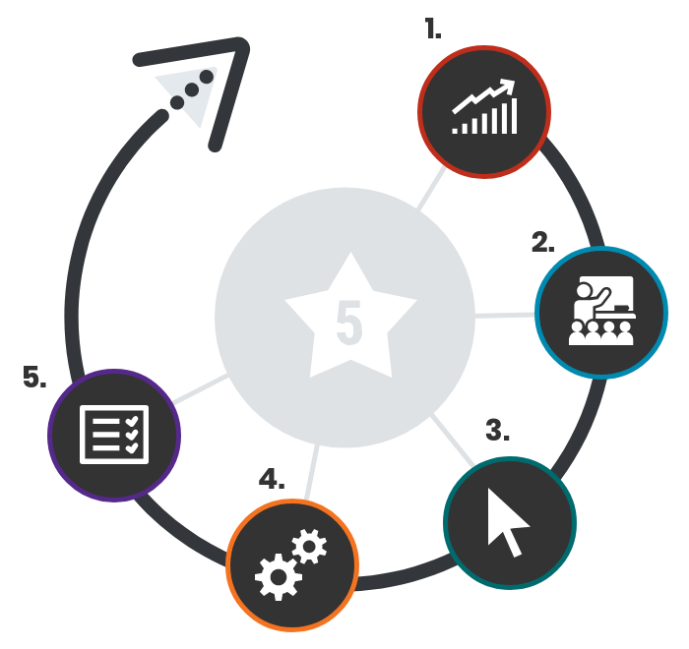

2. LEARN: How did educators learn about new and existing accessibility supports? ________________________________________________________________________________________________________________________________________________________________________________________________

3. SELECT: Which accessibility supports were selected for…

INSTRUCTION? ____________________________________________________________________________________________________________
ASSESSMENT?
________________________________________________________________________________________________________________________________________________
4. ADMINISTER: How effective was the administration and use of the selected supports during…
INSTRUCTION? ____________________________________________________________________________________________________________
ASSESSMENT?
________________________________________________________________________________________________________________________________________________

Appendices

Appendix A: Federal Laws

Documenting Accessibility Supports Under the Individuals with Disabilities Education Act (IDEA)

The Present Levels of Academic Achievement and Functional Performance (PLAAFP) is a federal requirement in which collaborative team members must stat “how the child’s disability affects the child’s involvement and progress in the general education curriculum—the same curriculum as non-disabled children” [Sec. 614 (d) (1) (A) (i) (I)]. Depending on the design and overall format of a typical IEP, there are potentially three areas in which accessibility supports can be addressed:

1. “Consideration of Special Factors” [Sec. 614 (d) (3) (B)]. This is where communication and assistive technology supports are considered.
2. “Supplementary Aids and Services” [Sec. 602 (29) and Sec. 614 (d) (1) (A) (i)]. This area of the IEP includes “aids, services, and other supports that are provided in regular education classes or other education-related settings to enable children with disabilities to be educated with nondisabled children to the maximum extent appropriate.”
3. “Participation in Assessments” [Sec. 612 (a) (17)]. This section of the IEP documents accommodations needed to facilitate the participation of students with disabilities in general state and district-wide assessments.

TO CUSTOMIZE THIS MANUAL, INSERT IN THIS BOX
(OR DELETE):

CURRENT STATE POLICY ON DOCUMENTING
ACCESSIBILITY SUPPORTS ON A STUDENT’S IEP

Documenting Accessibility Supports on a Student’s 504 Plan

Section 504 of the Rehabilitation Act of 1973 requires public schools to provide certain accessibility supports to students with disabilities even if they do not qualify for special education services under IDEA. All IDEA students are also covered by Section 504, but not all Section 504 students are eligible for services under IDEA. Section 504 states:

No otherwise qualified individual with a disability in the United States shall, solely by reason of her or his disability, be excluded from participation in, be denied the benefits of, or be subjected to discrimination under any program or activity receiving federal financial assistance. [29 U.S.C. Sec. 794 (a)]

Examples of the types of conditions for which students may receive designated features or accommodations, based on their 504 accommodation plan, include:

- allergies or asthma;
- attention difficulties;
- communicable diseases (e.g., hepatitis);
- drug or alcoholic addictions, but not currently using illegal drugs; and
- temporary disabilities due to accidents.

TO CUSTOMIZE THIS MANUAL, INSERT IN THIS BOX
(OR DELETE):

CURRENT STATE POLICY OR OTHER RESOURCES ON
DOCUMENTING ACCOMMODATIONS ON A STUDENT’S 504 PLAN

Federal Laws, Legal Cases, and Federal Guidance on Student Participation

Federal Laws

ESSA  https://www.congress.gov/114/crpt/hrpt354/CRPT-114hrpt354.pdf | The Every Student Succeeds Act (ESSA) was issued on December 10, 2015. It reauthorizes the 50-year-old Elementary and Secondary Education Act (ESEA), the national education law, and commitment to equal opportunity for all students. The bill mandates annual reporting of disaggregated data of groups of students, generating information about whether all students are achieving and whether schools are meeting the needs of low-income students, students of color, students with disabilities, and English learners. Specific ESSA requirements include provisions for:  (I) the participation in such assessments of all students;  (II) the appropriate accommodations, such as interoperability with, and ability to use, assistive technology, for children with disabilities (as defined in section 602(3) of the Individuals with Disabilities Education Act (20 U.S.C. 1401(3))), including students with the most significant cognitive disabilities, and students with a disability who are provided accommodations under an Act other than the Individuals with Disabilities Education Act (20 U.S.C. 1400 et seq.), necessary to measure the academic achievement of such children relative to the challenging State academic standards or alternate academic achievement standards described in paragraph (1)(E); and  (III) the inclusion of English learners, who shall be assessed in a valid and reliable manner and provided appropriate accommodations on assessments administered to such students under this paragraph, including, to the extent practicable, assessments in the language and form most likely to yield accurate data on what such students know and can do in academic content areas, until such students have achieved English language proficiency…
IDEA  https://www2.ed.gov/policy/speced/leg/idea/idea.pdf | IDEA specifically governs services provided to students with disabilities. Accountability at the individual level is provided through IEPs developed on the basis of each child’s unique needs. IDEA requires the participation of students with disabilities in state- and district-wide assessments. Specific IDEA requirements include:  Children with disabilities are included in general state and district-wide assessment programs, with appropriate accommodations, where necessary [Sec. 612 (a) (16) (A)]. The term ‘individualized education program’ or ‘IEP’ means a written statement for each child with a disability that is developed, reviewed, and revised in accordance with this section and that includes…a statement of any individual modifications in the administration of state or district-wide assessments of student achievement that are needed in order for the child to participate in such assessment; and if the IEP Team determines that the child will not participate in a particular state or district-wide assessment of student achievement (or part of such an assessment), a statement of why that assessment is not appropriate for the child; and how the child will be assessed [Sec. 614 (d) (1) (A) (V) and VI)].  For the small group of students with significant cognitive disabilities who are also English learners, these assessments will be an important tool to measure their progress in learning English.  IDEA, 34 CFR §§300.160(b)(2)(i) and (ii)  (2) The State's (or, in the case of a district-wide assessment, the LEA's) guidelines must:  (i) Identify only those accommodations for each assessment that do not invalidate the score; and  (ii) Instruct IEP teams to select, for each assessment, only those accommodations that do not invalidate the score.
Section 504 of the 1973 Rehabilitation Act and the Americans with Disabilities Act  https://www2.ed.gov/about/offices/list/ocr/docs/504-resource-guide-201612.pdf  https://www2.ed.gov/policy/speced/leg/rehab/rehabilitation-act-of-1973-amended-by-wioa.pdf  https://www.llsdc.org/assets/sourcebook/crs-rl34041.pdf | Section 504 provides individuals with disabilities with certain rights and protects individuals with disabilities against discrimination in federally funded programs and activities. Section 504 states:  No otherwise qualified individual with a disability in the United States, as defined in section 705(20) of this title, shall, solely by reason of her or his disability, be excluded from the participation in, be denied the benefits of, or be subjected to discrimination under any program or activity receiving federal financial assistance or under any program or activity conducted by any executive agency…  In school settings, 504 legislation guarantees and protects students with disabilities who may not otherwise have an IEP but are still considered an individual with disabilities. The definition of a student with disabilities is much broader under 504 than it is under IDEA. An important part of the 504 plans developed by schools for students with disabilities is often the lists of accommodations that the student can use on assessments.  Section 504 of the Rehabilitation Act of 1973 (Section 504) and the Americans with Disabilities Act (ADA) ensure a level playing field for students with disabilities in a wide range of settings, including testing, and, similarly to IDEA, provide for reasonable testing accommodations to be given to students with disabilities as outlined/as needed. Title III of the ADA requires equal access and participation. The IEP/504 team is charged with making accommodations decisions for all IDEA/504 eligible students every year, as part of the annual IEP/504 process.
Legal Cases

Lau v. Nichols (1974) | The Office of Civil Rights established a policy for the provision of equal educational opportunities for ELs. This policy was described in a memorandum in 1970:  Where the inability to speak and understand the English language excludes national origin minority group children from effective participation in the educational program offered by a school district, the district must take affirmative steps to rectify the language deficiency in order to open its instructional program to these students.  This memorandum does not tell districts what steps they must take to ensure the equal opportunities for ELs. However, it does state that the law is violated if:  - students are excluded from effective participation in school because of their inability to speak and understand the language of instruction;  - national origin-minority students are inappropriately assigned to special education classes because of their lack of English skills;  - programs for students whose English is less than proficient are not designed to teach them English as soon as possible, or if these programs operate as a dead-end track; or  - parents or guardians whose English is limited do not receive school notices or other information in a language they can understand.  This law was tested in the Supreme Court Case, Lau v. Nichols. In 1974, the Supreme Court upheld this law, supporting the premise that if students cannot understand the language of instruction, they do not have access to an equal opportunity education. The Supreme Court said the following:  There is no equality of treatment merely by providing students with the same facilities, textbooks, teachers, and curriculum; for students who do not understand English are effectively foreclosed from any meaningful education.  All students in the United States, regardless of native language, have the right to a quality education. An equal education is only possible when students are able to understand the language of instruction.
Castañeda v. Pickard (1981) | On June 23, 1981, the Fifth Circuit Court issued a decision that is the seminal post-Lau decision concerning education of language-minority students. The case established a three-part test to evaluate the adequacy of a district’s program for EL students:  - Is the program based on an educational theory recognized as sound by some experts in the field or is it considered by experts as a legitimate experimental strategy?  - Are the programs and practices, including resources and personnel, reasonably calculated to implement this theory effectively?  - Does the school district evaluate its programs and make adjustments where needed to ensure language barriers are actually being overcome?
Brookhart v. Illinois State Board of Education (1983) | This case demonstrated the necessary steps that a district is required to take in order to ensure that students with disabilities are prepared for graduation standards. School districts need to pay careful attention to ensure that students are aware of diploma requirements, and IEPs need to be written with these specific graduation requirements in mind.
Federal Guidance

Questions and Answers Regarding Inclusion of English Learners with Disabilities in English Language Proficiency Assessments and Title III Annual Measurable Achievement Objectives | This joint guidance document developed by the Office of Elementary and Secondary Education (OESE) and the Office of Special Education and Rehabilitative Services (OSERS) was released on July 18, 2014 to help states and local educational agencies understand how Part B of the IDEA and Titles I and III of the ESEA address the inclusion of ELs with disabilities in annual state ELP assessments.  The 2014 guidance was amended by the July 2015 Addendum. The two documents address states’ general obligations around including ELs with disabilities in ELP assessments, responsibilities of IEP teams, accommodations and alternate assessments, exit from EL status, annual measurable achievement objectives, initial identification, and other considerations.
Dear Colleague Letter on the  Nondiscriminatory Administration of School Discipline | Issued on January 7, 2015 by the U.S. Department of Justice and the U.S. Department of Education, this document covers state and local educational agencies’ obligations to EL students and addresses common civil rights issues. A separate section of the document discusses the issue of evaluating ELs for special education services and providing special education and English language services. This document is accompanied by resources for students and parents or guardians available in multiple languages.
Dear Colleague Letter on FAPE/IEP Alignment | Issued on November 16, 2015 by the U.S. Department of Education (the Office of Special and Rehabilitative Services), this document addresses the entitlement of each eligible child with a disability to a free appropriate public education (FAPE) aligned with the child’s individualized education program (IEP).
Americans with Disabilities Act Requirements: Testing Accommodations | Issued in September 2015 by the Department of Justice, this is the Department’s response to questions and complaints about excessive and burdensome documentation demands, failures to provide needed accommodations, and failures to respond to requests for testing accommodations in a timely manner. The guidance applies to testing entities (private, state, local) that have exams related to applications, licensing, certification, or credentialing for secondary, postsecondary, professional, or trade purposes.
English Learner Tool Kit | This document was jointly developed by the Department of Education and Department of Justice and issued in September 2015 to help state and local education agencies help ELs by fulfilling the obligations in the Dear Colleague Letter of January 7, 2015. The tool kit includes 10 chapters, one for each of the “common civil rights issues” discussed in the January 7, 2015 ‘Dear Colleague’ Letter.
Peer Review of State Assessment Systems | This guidance was issued in September 2015 by the Office of Elementary and Secondary Education (OESE) and is required by ESEA Section 1111(e) to ensure the technical soundness of each State’s assessment system. This version was revised after the previous version was suspended in December 2012. The document is reorganized, and includes updates based on revised professional standards.

Appendix B: Universal Features

Note: The accessibility supports included in these tables may, in some cases, belong to different tiers or be prohibited, depending on state policies and assessment types. In several instances, similar supports are grouped for the sake of clarity. See Tool 1 for more detail about the tiers.

Embedded Universal Features Available to All Students
Universal Feature | Description
Amplification | The student raises or lowers the volume control, as needed, using headphones.
Breaks | Testing systems can be programmed to allow for students to take breaks after completing a flexibly designated number of assessment items. The number of assessment items per session can be flexibly defined, based on the student’s need. When breaks are longer than certain time limits, the student may be prevented from returning to items already attempted. There is no limit on the number of breaks that a student might be given. The use of this universal feature may result in the student needing additional overall time to complete the assessment.
Calculator | Student can click on a button to activate an embedded, on-screen digital calculator for test items which permit the use of a calculator. When the embedded calculator, as presented for all students, is not appropriate for a student (for example, for a student who is blind), the student may access the calculator through the use of assistive technology devices (such as a talking calculator or a braille calculator).
Digital notepad | The student uses this feature as virtual scratch paper to make notes or record responses.
Eliminate answer choices/ Strikethrough | The student uses this feature to eliminate any answer choices which do not appear correct to the student.
English dictionary | An English dictionary is available for the student’s use. Note that use of this universal feature may result in the student needing additional overall time to complete the assessment.
English glossary | Grade- and context-appropriate definitions of specific, construct-irrelevant terms are shown in English on the screen via a pop-up window. The student can access the embedded glossary by clicking on any of the pre-selected terms. The use of this feature may result in the student needing additional overall time to complete the assessment.
Expandable passages | The student is able to expand each passage so that it takes up a larger portion of the screen as the student reads. The student can then retract the screen to its original size.
Global notes | Notes are retained from segment to segment, so that the student’s personal notes are still available, even though the student is not able to go back to specific items in the previous segment.
Highlighter | The student uses this digital feature for marking desired text, items, or response options with a color.
Keyboard navigation | The student is able to navigate throughout test content by using a keyboard, e.g., arrow keys. The functionality of this feature may differ, depending on the testing platform.
Line reader/Line reader mask tool/Line guide | The student is able to use this feature as a guide when reading text.
Mark for review/Flag for review | The student is able to flag items for future review during the assessment.
Math tools | These digital tools (i.e., embedded ruler, embedded protractor) are used for measurements related to math items. They are available for use on only those test items for which one or more of these tools would be appropriate.
Spellcheck | Writing tool for checking the spelling of words in student-generated responses. Spellcheck only indicates that a word is misspelled; it does not provide the correct spelling.
Writing tools | The student uses writing tools to format and edit written responses, including cut-and-paste, copy, underline, Italicize, bold, and undo/redo.
Zoom (item level) | The student can enlarge the size of text and graphics on a given screen. This feature allows students to view material in magnified form on an as-needed basis. The student may enlarge test content at least four-fold, and on some platforms more. The system allows magnifying features to work in conjunction with other accessibility features and accommodations provided.

Non-Embedded Universal Features Available to All Students
Universal Feature | Description
Breaks | Breaks may be given at predetermined intervals or after completing sections of the assessment. Sometimes an individual student is allowed to take breaks as needed to reduce cognitive fatigue. The use of this universal tool may result in the student needing additional overall time to complete the assessment.
English dictionary | An English dictionary can be provided to the student. The use of this universal feature may result in the student needing additional overall time to complete the assessment.
Noise buffer/ Headphones/Audio aids | The student uses noise buffers to minimize distraction or to filter out external noise during testing. Any noise buffer must be compatible with the hardware requirements and the test platform.
Scratch paper | The student uses scratch paper or an individual, erasable whiteboard to make notes or record responses. All scratch paper must be collected and securely destroyed after administration of each test domain to maintain test security. The student receives one sheet of scratch paper (or more as needed). A marker, pen, or pencil should be provided, as well. The student can use an assistive technology device to take notes instead of using scratch paper, as long as the device is approved by the state. Test administrators make sure that all the notes taken on an assistive technology device are deleted after the test.
Thesaurus | A thesaurus containing synonyms of terms used in the test can be provided to the student. The use of this universal tool may result in the student needing additional overall time to complete the assessment.

Appendix C: Designated Features

Note: The accessibility supports included in these tables may, in some cases, belong to different tiers or be prohibited, depending on state policies and assessment types. In several instances, similar supports are grouped for the sake of clarity. See Tool 1 for more detail about the tiers.

Embedded Designated Features Identified in Advance
Designated Feature | Description | Recommendations for Use
Answer-masking | The student is able to block off answer choices. | Students with attention difficulties may need to mask answer choices that may be distracting during the assessment. This feature also may be needed by students with print disabilities (including learning disabilities) or visual impairments.
Color contrast | The student is able to adjust the text color and screen background color based on the student’s need. | Students with attention difficulties may need this feature for viewing test content. It also may be needed by some students with visual impairments or other print disabilities (including learning disabilities). Choice of colors should be informed by evidence that specific text and background color combinations meet the student’s needs.
General masking | The student is able to block off content that is not of immediate need or that may be distracting. Masking allows students to hide and reveal individual answer options, as well as all navigational buttons and menus. Masking enables the student to focus attention on a specific part of a test item. | Students with attention difficulties may need to mask content which is not of immediate need or may be distracting during the assessment. This feature also may be needed by students with print disabilities (including learning disabilities) or visual impairments.
Text-to-speech/ Audio support/  Spoken audio | The student uses this feature to hear pre-recorded or generated audio of tasks. | Students who use text-to-speech supports will need headphones, unless they are being tested individually in a separate setting.
Turn off universal features | This feature facilitates the disabling of any universal feature that might be distracting to the student or could interfere with student performance. | Students who are easily distracted (regardless of whether they have attention difficulties or disabilities) may be overwhelmed by some of the universal features. In order to determine which features to turn off, it is important to have evidence based on prior knowledge of which specific features may be distracting.
Zoom (test-level) | The test platform is pre-set to an enlarged font size, prior to test administration. | Students with visual impairments may need to increase the size of text and other item features beyond the conventional “zoom” functionality that is a universal feature on the test platform. Note that a larger computer screen may be required to accommodate this feature.

Non-Embedded Designated Features Identified in Advance
Designated Feature | Description | Recommendations for Use
Bilingual dictionary | The student has access to a bilingual/dual-language, word-to-word dictionary as a support. | For students whose primary language is not English and who use dual-language supports in the classroom, use of a bilingual/dual-language, word-to-word dictionary may be appropriate. The use of this feature may result in the student needing additional overall time to complete the assessment.
Color contrast | Test content of online items may be printed with different colors. | Students with attention difficulties may need this support for viewing the test, if digitally-provided color contrasts do not meet their needs. Some students with visual impairments or other print disabilities (including learning disabilities) also may need this support. Choice of colors should be informed by evidence regarding which colors meet the student’s needs.
Color overlay | The student is able to overlay a semi-transparent color onto paper-based test content. | This designated feature works only with black text on white background.
Human reader/Human read-aloud/ Read aloud | The student accesses test content via read aloud by a qualified human reader. | Students who use the paper-and-pencil version of the test can have the same test content read aloud that is supported through audio in a computer-based version. If a human reader is selected, that person must have appropriate experience providing read-aloud support and must sign a document verifying adherence to state policy or practice to ensure test security and ethical practices.
Magnification device | The student adjusts the size of specific areas of the screen (e.g., text, formulas, tables, graphics) with an assistive technology device. | Students with visual impairments may need to increase the size of text and other item features beyond the conventional “zoom” setting that is a universal feature.
Native-language translation of directions | Translation of general test directions (not item prompts or questions) is a language support available to students prior to starting the actual test. Test directions can either be read aloud or signed by a test administrator who is fluent in the language or communicated electronically via the test platform. | Students who have limited English-language skills can use the translated directions feature.
Paper-and-pencil test | The student takes a paper-and-pencil version of the test. | Due to cultural considerations or to significantly limited technology skills, some students may need to take paper-and-pencil versions of assessments. This option should be based on a student’s individual needs only and should not be applied on a group basis.
Separate setting | Test location is altered, so that the student is tested in a setting different from that made available for most students. | Students who are easily distracted (or who may distract others) in a group test setting may need to take the assessment in an alternate location. The separate setting may be in the same room but in a different location (e.g., away from windows, doors, or pencil sharpeners; in a study carrel; near the teacher’s desk; at the front of a classroom); in a different, smaller-group setting; or in a room that allows them to work alone and/or to use a device requiring voicing (e.g., a Whisper Phone).  Some students may benefit from being in an environment that allows them to get up and walk around. In some instances, students may need to interact with instructional or test content in an environment outside of school, such as in a hospital or at home.
Student reads test aloud | The student reads the test content aloud. This feature must be administered in a one-on-one test setting. | Students who are beginning readers may need to hear themselves read aloud in order to comprehend the text. This support may also help students who tend to rush through assessments without fully reading the text.

Appendix D: Accommodations

Note: The accessibility supports included in these tables may, in some cases, belong to different tiers or be prohibited, depending on state policies and assessment types. In several instances, similar supports are grouped for the sake of clarity. See Tool 1 for more detail about the tiers.

Embedded Accommodations Available with an IEP or 504 Plan
Accommodation | Description |  | Recommendations for Use
American Sign Language (ASL) | Test content is translated into ASL video. ASL human signer and the signed test content are viewed on the same screen. Students may view portions of the ASL video as often as needed. |  | Students who are deaf or hard of hearing and who typically use ASL may need this accommodation when accessing text-based content on an assessment. For many students who are deaf or hard of hearing, viewing signs is the only way to access information that is being presented orally. The use of this accommodation may result in the student needing additional overall time to complete the assessment.  It is important to note, however, that some students who are hard of hearing will be able to listen to information presented orally—as long as they are provided with appropriate amplification and the test setting does not have any extraneous sounds that could interfere with clear presentation of the audio presentation on a listening test.
Closed captioning | Printed text that appears on the computer screen as audio materials are presented. |  | Students who are deaf or hard of hearing and who typically access information presented via audio by reading words may need this support to access audio content. For many students who are deaf or hard of hearing, viewing words (sometimes in combination with reading lips and ASL) is the way they access information presented orally. It is important to note, however, that some students who are hard of hearing will be able to listen to information presented orally—as long as they are provided with appropriate amplification and the test setting does not have any extraneous sounds that could interfere with clear presentation of the audio presentation on a listening test.
Streamline | This accommodation provides a streamlined interface of the test in an alternate, simplified format in which the items are displayed below the stimuli. |  | This accommodation may benefit a small number of students who have specific learning or reading disabilities and need text that is presented in a more sequential format.
Unlimited re-recordings | The student is able to re-record answers in the speaking domain an unlimited number of times. |  | Students whose disabilities preclude them from being able to record their answers on the first or second attempt (as available in the non-accommodated version of the test) may need to rerecord their answers multiple times.
Unlimited replays | The student is able to replay items in the listening domain an unlimited number of times. |  | Students whose disabilities preclude them from being able to respond to a listening item on the first or second attempt (as available in the non-accommodated version of the test) may need a testing accommodation which enables them to replay items multiple times.
Word-prediction |  | The student uses a word-prediction feature that provides a bank of frequently- or recently-used words on screen after the student enters the first few letters of a word. | Students with physical disabilities that severely limit them from writing or keyboarding responses or who have disabilities that severely prevent them from recalling, processing, or expressing written language may need this support.

Non-Embedded Accommodations Available with an IEP or 504 Plan
Accommodation | Description | Recommendations for Use
Abacus | This accommodation may be used in place of scratch paper for students who typically use an abacus. | Some students with visual impairments.
Assistive technology | The student is able to use assistive technology, which includes such supports as typing on customized keyboards, assistance with using a mouse, mouth or head stick or other pointing devices, sticky keys, touch screen, trackball, speech-to-text conversion, and/or voice recognition. | Students who have dexterity difficulties may need an alternative device.
Braille | A raised-dot code that individuals read with the fingertips. Graphic material (e.g., maps, charts, graphs, diagrams, illustrations) is presented in a raised format (paper, thermoform, or refreshable braille). Both contracted and un-contracted braille (English Braille, American Edition) are available; Unified English Braille will be adopted for future assessments. Nemeth code is available for math. | Students who are blind or have low vision may read text via braille. Tactile overlays and graphics also may be used to assist the student in accessing content through touch. The use of this accommodation may result in the student needing additional overall time to complete the assessment.
Braille writer or note-taker | A blind student uses a braille writer or note-taker with the grammar checker, internet, and file-storing functions deactivated. | Students should number their responses to be sure that their answers can be transcribed accurately into a scorable test booklet or answer document.
Calculator/  Calculation device | A student uses a specific calculation device other than the embedded, grade-level calculator (e.g., large-key, talking, or another adapted calculator). | Students with visual impairments or dexterity issues who are unable to use the embedded calculator for calculator-allowed items will be able to use the calculator that they typically use, such as a braille calculator or a talking calculator. Test administrators should ensure that the calculator is available only for designated, calculator-use items.
Extended time | Students have until the end of the school day to complete a single test unit. | Students should be tested in a separate setting to minimize distractions to other students and should be scheduled for testing in the morning to allow adequate time for completion of a test by the end of the school day.
Human signer/Sign language/Sign interpretation of test | A human signer signs the test directions to the student. The student may also dictate responses by signing. | The student must be tested in an individual or small-group setting.
Large-print test booklet | A large-print form of the test that is provided to the student with a visual impairment. | Students with visual impairments who may not be able to use zoom or magnifying devices to access the test and may need a large-print version of their particular test form.
Multiplication table | A paper-based, single-digit (1-9) multiplication table is available to the student. | This accommodation can benefit students with a documented and persistent calculation disability (i.e., dyscalculia).
Print on request/Print on demand | The student uses paper copies of individual test items. | This feature is contingent on state policy or practice. Students may not be able to interact with items online (due to visual impairments, lack of familiarity with the computer-based format, or other reasons), and as a result may need a paper copy of test items. The use of this feature may result in the student needing additional time to complete the assessment.
Scribe | The student dictates her/his responses to an experienced educator who records verbatim what the student dictates. | Students who have documented, significant motor or language-processing difficulties, or who have had a recent injury (such as a broken hand or arm) that makes it difficult to produce responses may need to dictate their responses to a human, who then records the student’s responses verbatim, either in the test platform or on paper. The use of this accommodation may result in the student needing additional time to complete the assessment.
Speech-to-text | The student uses an assistive technology device to dictate responses or give commands during the test. | Students who have documented motor or processing disabilities (such as dyslexia) or who have had a recent injury that makes it difficult to produce text or use computer keys may need alternative ways to work with computers.  Note that, if students use their own assistive technology devices, all assessment content should be deleted from these devices after the test for security purposes.
Word-prediction external device | The student uses an external word-prediction device that provides a bank of frequently- or recently-used words on screen after the student enters the first few letters of a word. | Students with physical disabilities that severely limit them from writing or keyboarding responses or who have disabilities that severely prevent them from recalling, processing, or expressing written language may need this support.

Appendix E: Glossary of Terms and Acronyms

The following list defines terms and acronyms used throughout this document. States may vary in their definitions, may use state-specific criteria, and/or may use different terms and acronyms.

TO CUSTOMIZE THIS MANUAL, INSERT IN THIS BOX
(OR DELETE):

CURRENT STATE TERMS AND ACRONYMS

504 Plan: Sometimes called a 504 accommodation plan, comes from section 504 of the Rehabilitation Act of 1973 requiring public schools to provide certain accessibility supports to students with disabilities even if they do not qualify for special education services under IDEA.

accessibility: The reduction or elimination of barriers that prevent students from demonstrating what they know and can do.

accessibility supports: Supports do not reduce or change learning expectations but rather meet specific needs of students and enable a student's work to be a valid measure of what the student knows and can do.

accommodations: Changes in procedures or materials that ensure equitable access to instructional and assessment content and generate valid assessment results for students who need them. They do not reduce expectations for learning.

alternate assessment: A test designed for students with the most significant cognitive disabilities with a reduced depth and breadth from the general assessment.

assessment: An evaluation or test of what a person knows and can do in regard to a specific content area or used to estimate a specific quality about a person.

construct: A construct is a hypothesized, non-material cause of an observable behavior. It is not a physical entity with length, mass, depth, etc. that can be directly measured. For example, grade 3 math knowledge is the hypothetical cause for a student answering grade 3 math questions correctly.

content: The material covered in class (e.g., math, reading, art, etc.).

designated feature: Features that are available for use by any student for whom the need has been indicated by an educator (or team of educators, including the parents or guardians and the student, when appropriate) who is familiar with the student’s characteristics and needs.

EL(s): English learner(s) are students whose native language is not English and who do not yet possess sufficient English language proficiency to fully access curriculum that is in English.

ELP: English language proficiency

ELs with disabilities: Students whose native language is not English, who do not yet possess sufficient English language proficiency to fully access content that is in English, and who have disabilities served by IDEA or Section 504.

embedded feature: A feature that is part of the technology delivery of the instruction or assessment.

general education students: Students who do not have an identified disability or EL status. Although students with disabilities, ELs, and ELs with disabilities are also general education students, within this document this term is a simple way to refer to students who do not have a disability, are not identified as an EL, or who are not identified as an EL with a disability.

IDEA: Individuals with Disabilities Education Act.

IEP: Individualized Education Program - A federally required document for any student with a disability that outlines the resources and services a student needs in order to access the curriculum.

modifications: Changes in practices or materials that lower or reduce state-required learning expectations.

Non-embedded feature: A support that is provided locally and not through the technology delivery of the instruction or assessment.

PLAAFP: Present Levels of Academic Achievement and Functional Performance; a federal requirement in which collaborative team members must state “how the child’s disability affects the child’s involvement and progress in the general education curriculum—the same curriculum as non-disabled children” [Sec. 614 (d) (1) (A) (i) (I)].

PNP: Personal Needs Profile - A generic term used to reference documented accessibility needs for any student. Some states or districts may have specific templates and activities for PNP development.

significant cognitive disabilities: Students with significant cognitive disabilities cannot be identified by looking at disability categorical labels that were identified by the Individuals with Disabilities Education Act (IDEA). Generally, the primary disability categories of many students with significant cognitive disabilities are intellectual disabilities, autism, and multiple disabilities. Not all students in any of these categories have significant cognitive disabilities. Additionally, some students with the most significant cognitive disabilities are in other categories such as deaf-blindness. Students with most significant cognitive disabilities participate in the alternate assessment based on alternate academic achievement standards (AA-AAAS).

standardized: The uniform administration procedures and conditions during an event such as an assessment to produce comparable information about student learning.

standards: Educational targets outlining what all students are expected to master at each grade level.

students with disabilities: Students who are eligible to receive services identified through the Individuals with Disabilities Education Act (IDEA) or Section 504 of the Rehabilitation Act.

universal design: Policies and practices that are intended to improve access to learning and assessments for all students and reduce the need for accommodations.

universal feature: Accessibility supports that are available to all students as they access instructional or assessment content. States may have additional, specific criteria that define accessibility supports identified as universal features.

Retrieved October 6, 2020, from: www2.ed.gov/policy/speced/guid/idea/memosdcltrs/q-and-a-on-elp-swd.doc
Retrieved October 6, 2020, from: www2.ed.gov/programs/sfgp/elswdfaq8032015.doc
Retrieved October 6, 2020, from: https://www2.ed.gov/about/offices/list/ocr/letters/colleague-el-201501.pdf
Retrieved October 6, 2020, from: https://sites.ed.gov/idea/idea-files/osep-dear-colleague-letter-on-free-and-appropriate-public-education-fape/
Retrieved October 6, 2020, from: http://www.ada.gov/regs2014/testing_accommodations.html
Retrieved October 6, 2020, from: https://www2.ed.gov/about/offices/list/oela/english-learner-toolkit/index.html
Retrieved October 6, 2020, from: https://www2.ed.gov/policy/elsec/guid/assessguid15.pdf

